Ulvi Bajarani

SID 20539914

CSCI 6345 – Advanced Computer Networks

Summer II

Assignment 8

Introduction to Cisco Packet Tracer

Chapter 1.0.1.1 Preview

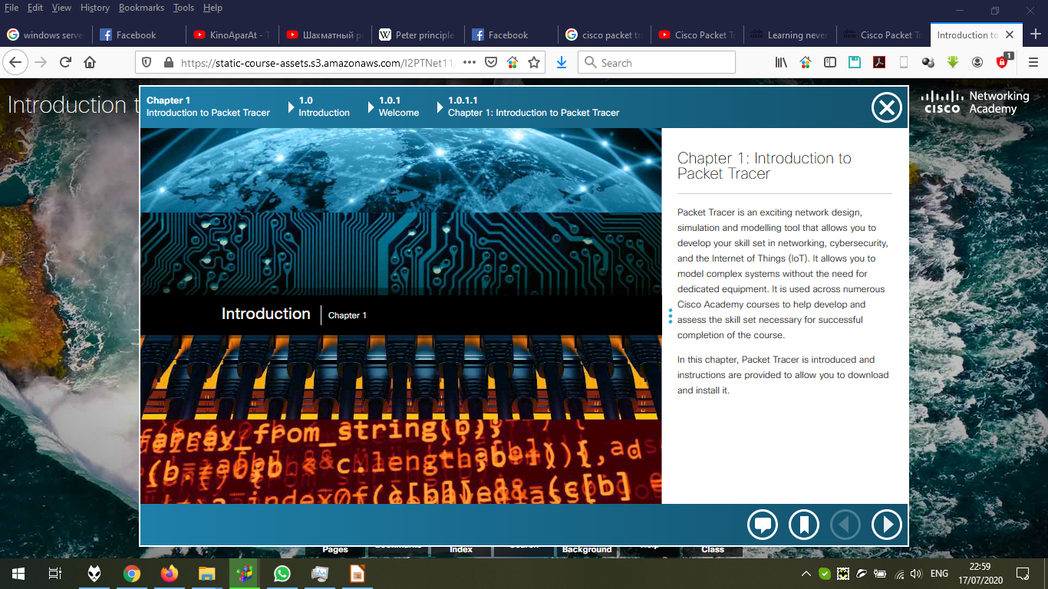

Chapter 1.1.1.1 Preview

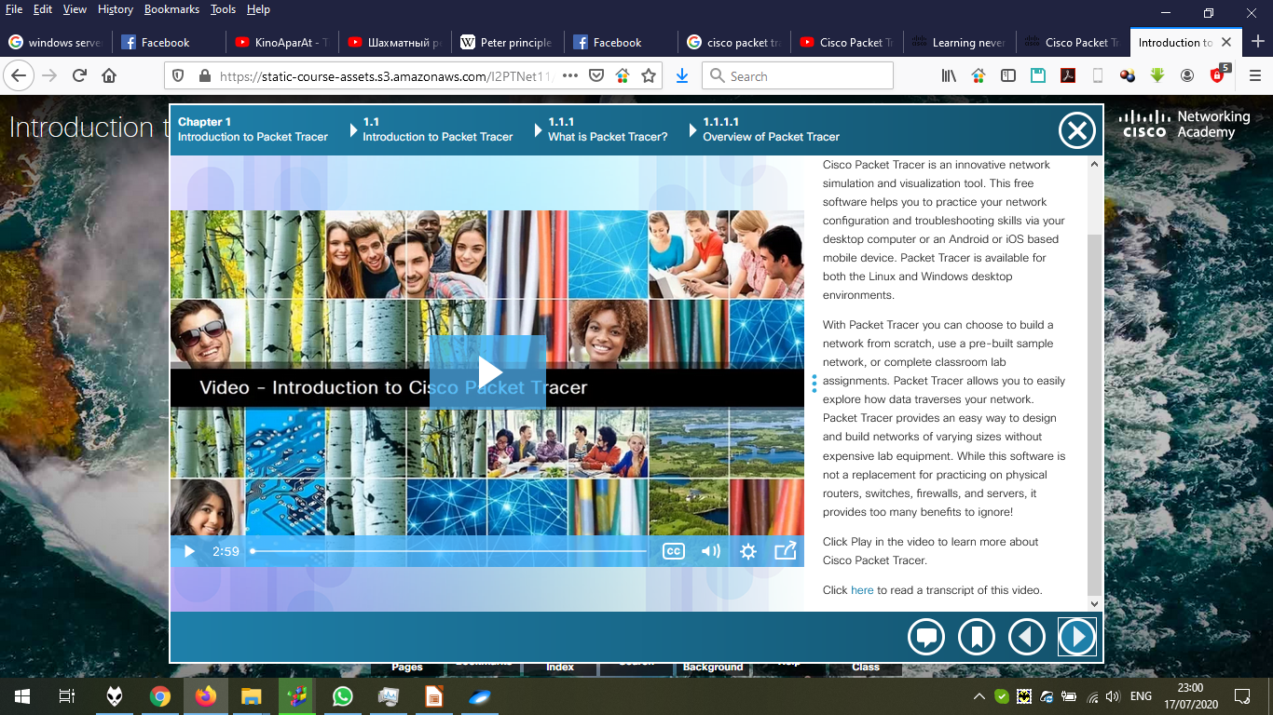

Chapter 1.1.2.1 Preview

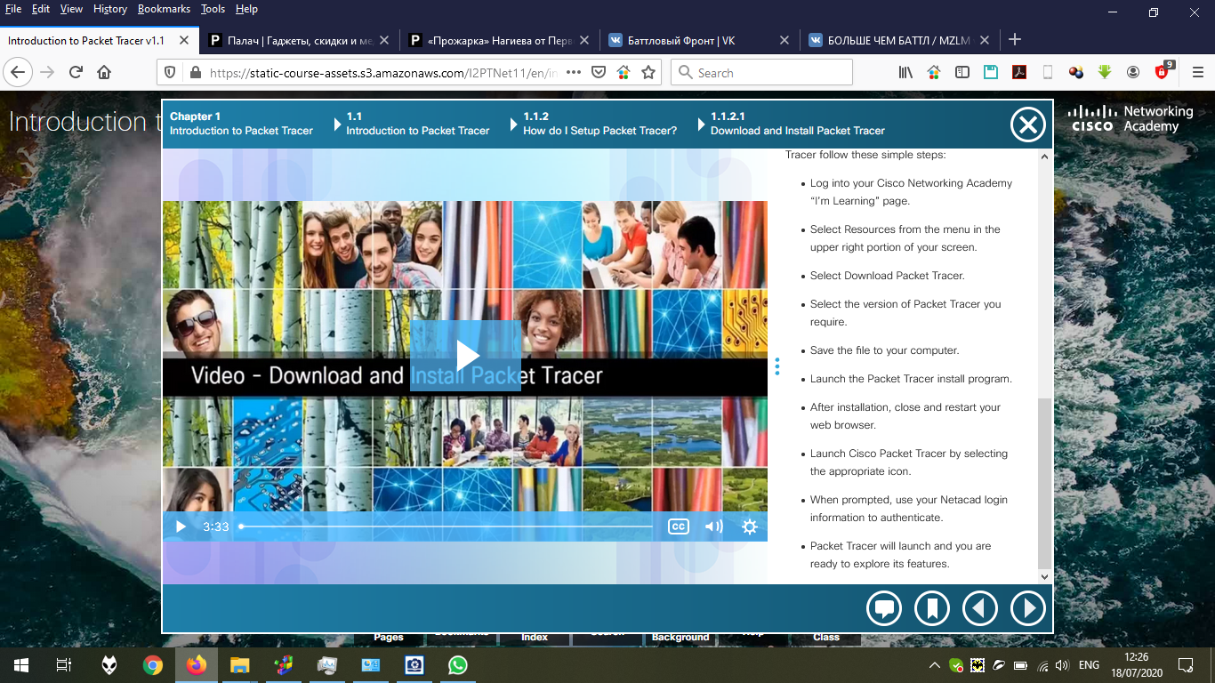

To download the software, we go to the course page, and click resourses.

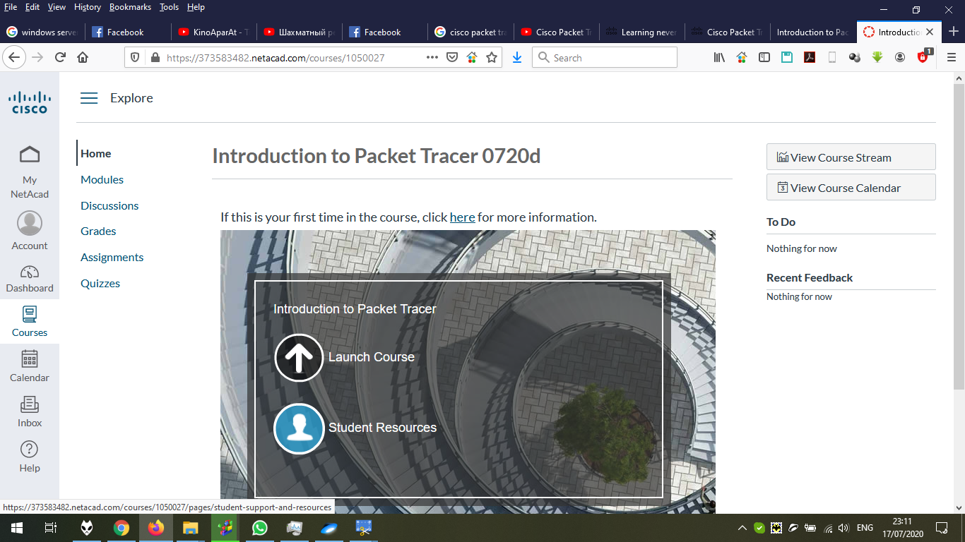

In resources, we go bottom and click “Download and install the latest version of Packet Tracer”

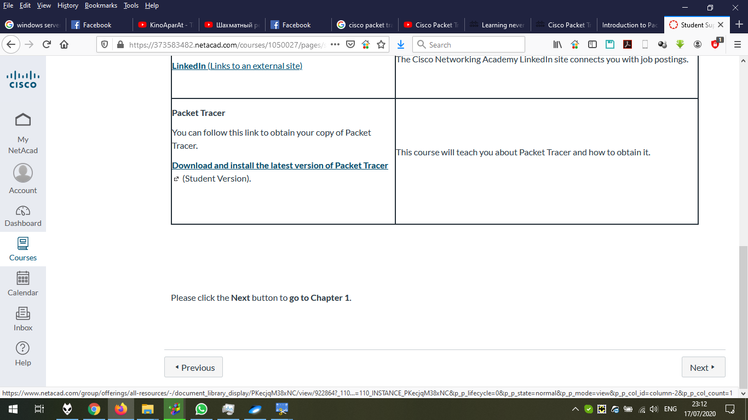

Click on “Packet Tracer Resources”:

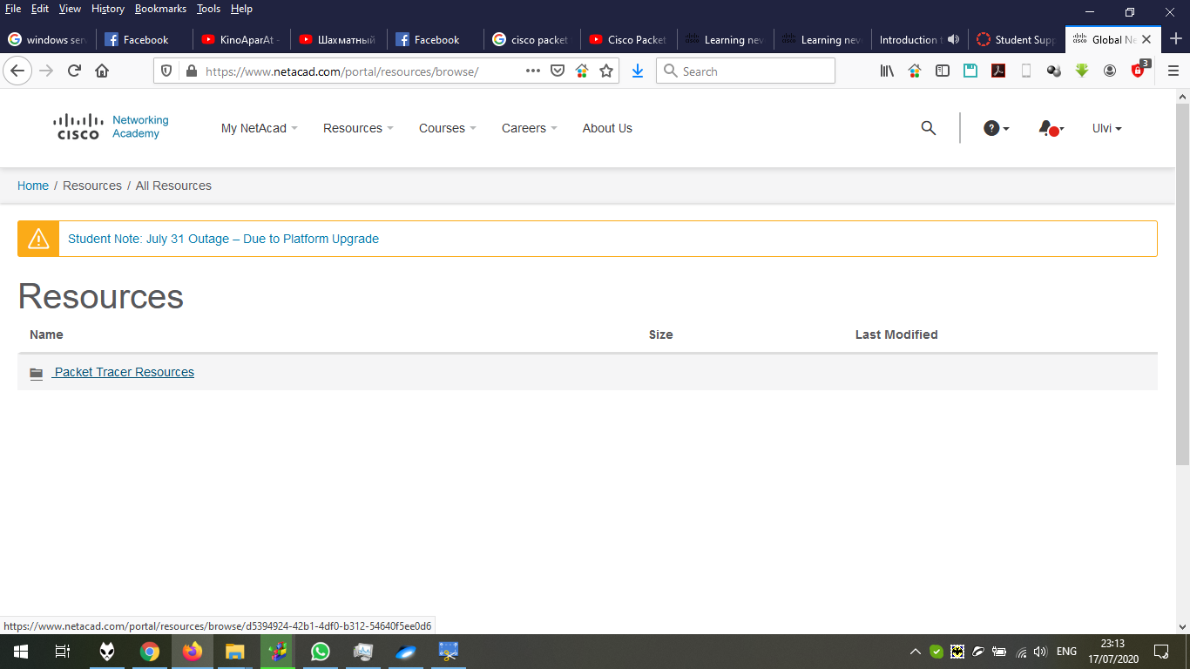

Here, we define the version. Click on “PT Desktop”:

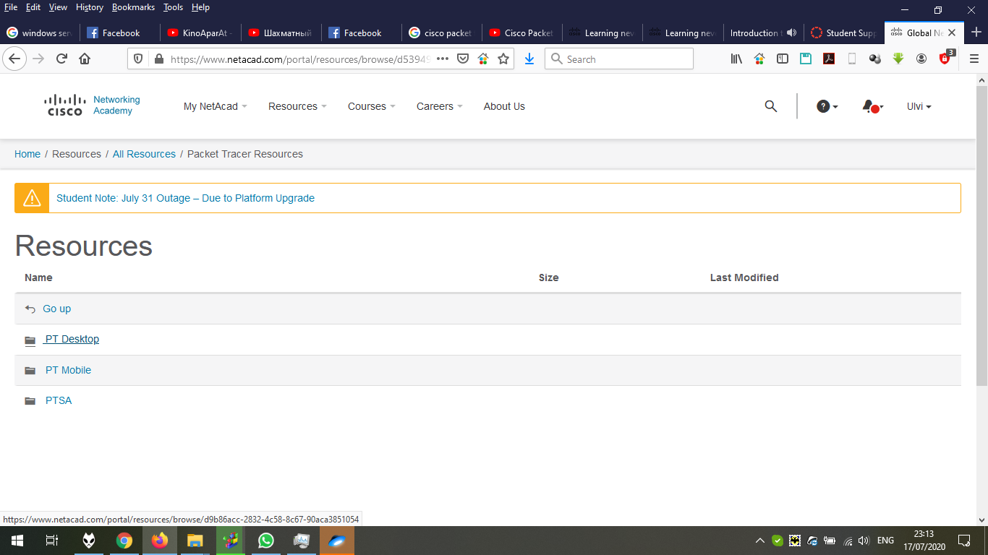

Choose the version. In my case, 7.3.0:

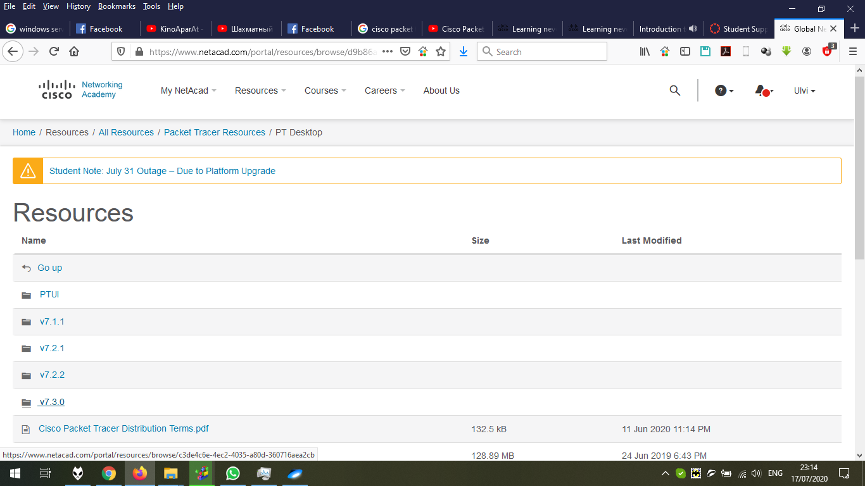

And now, we choose “PacketTracer-7.3.0-win64-setup.exe”:

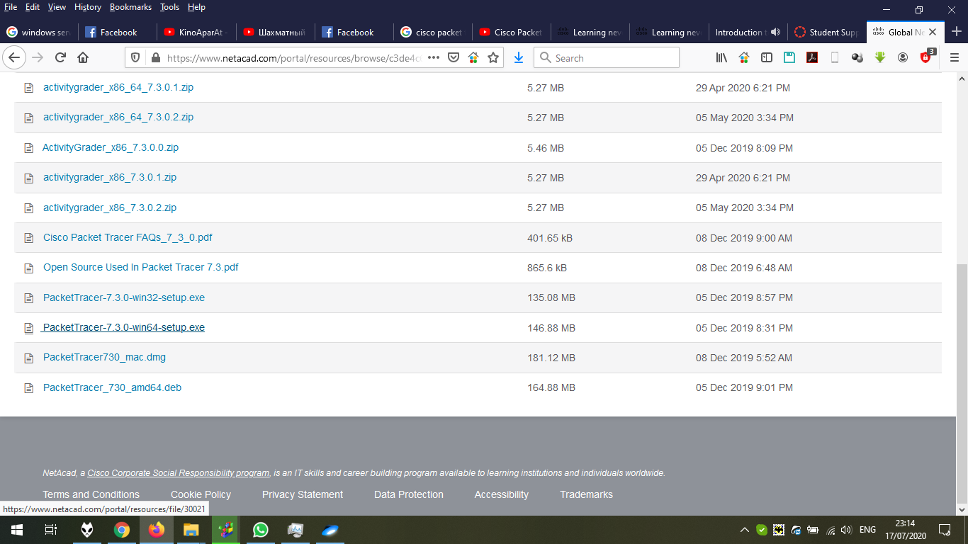

After opening the file, we click “Accept”.

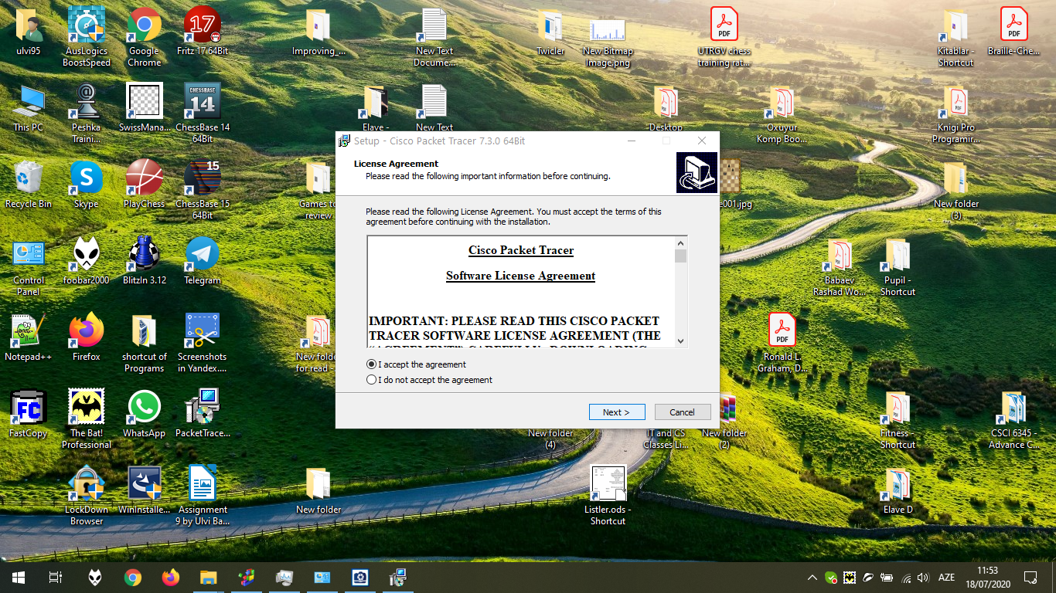

We either define the path and click “Next” or do it directly:

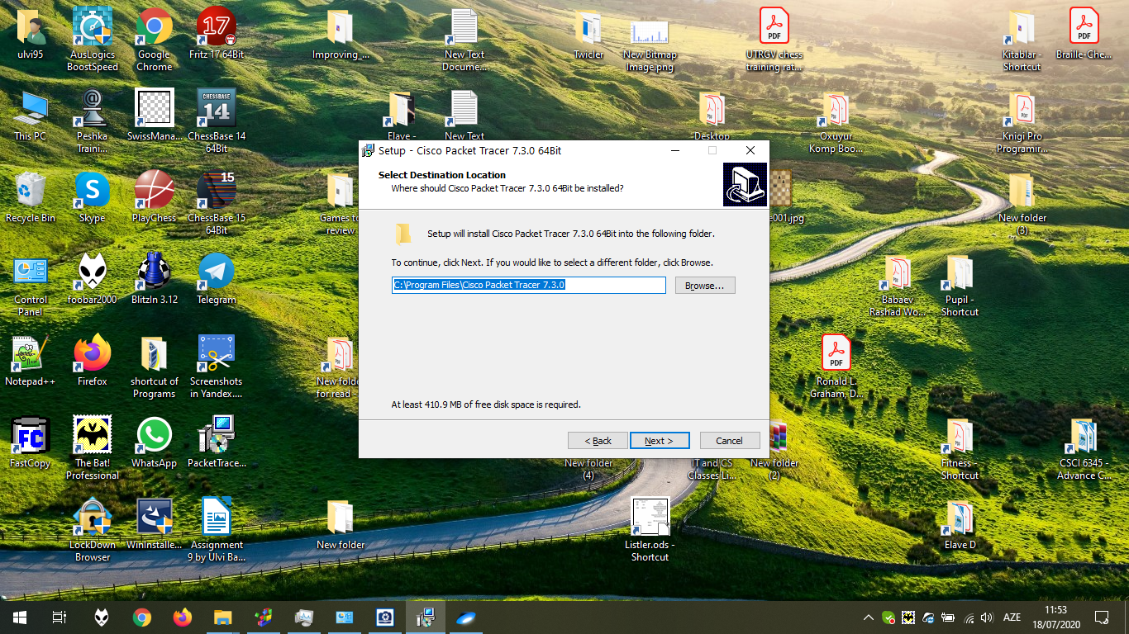

We either define the Start Menu path and click “Next” or do it directly:

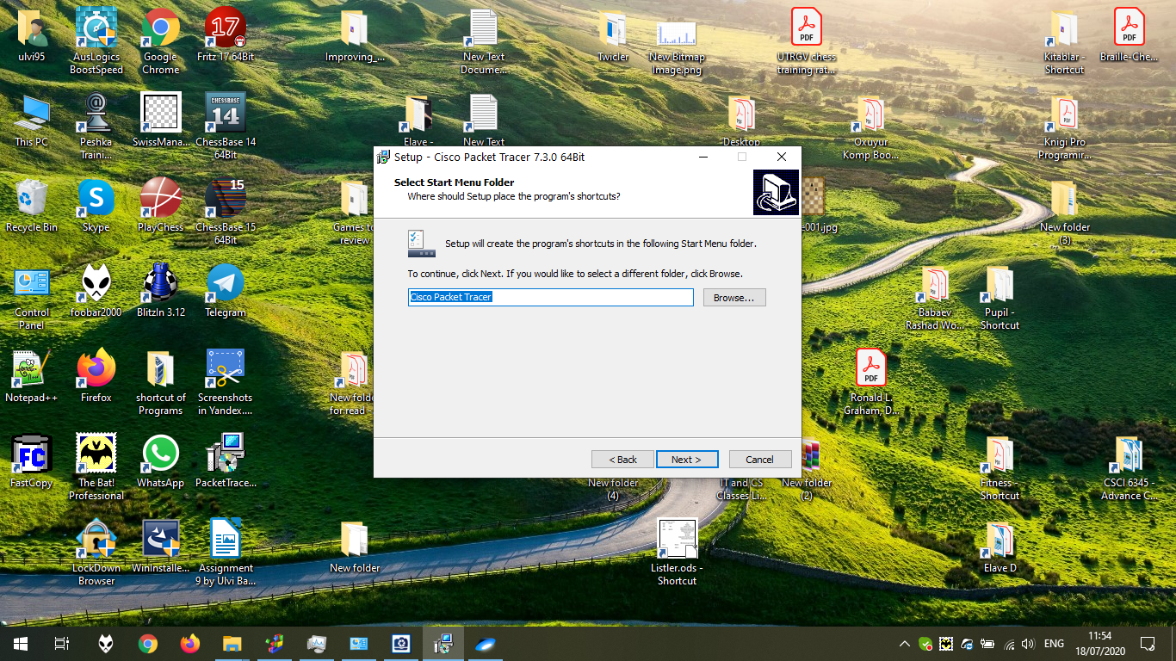

Click “Next” after defining all shortcuts:

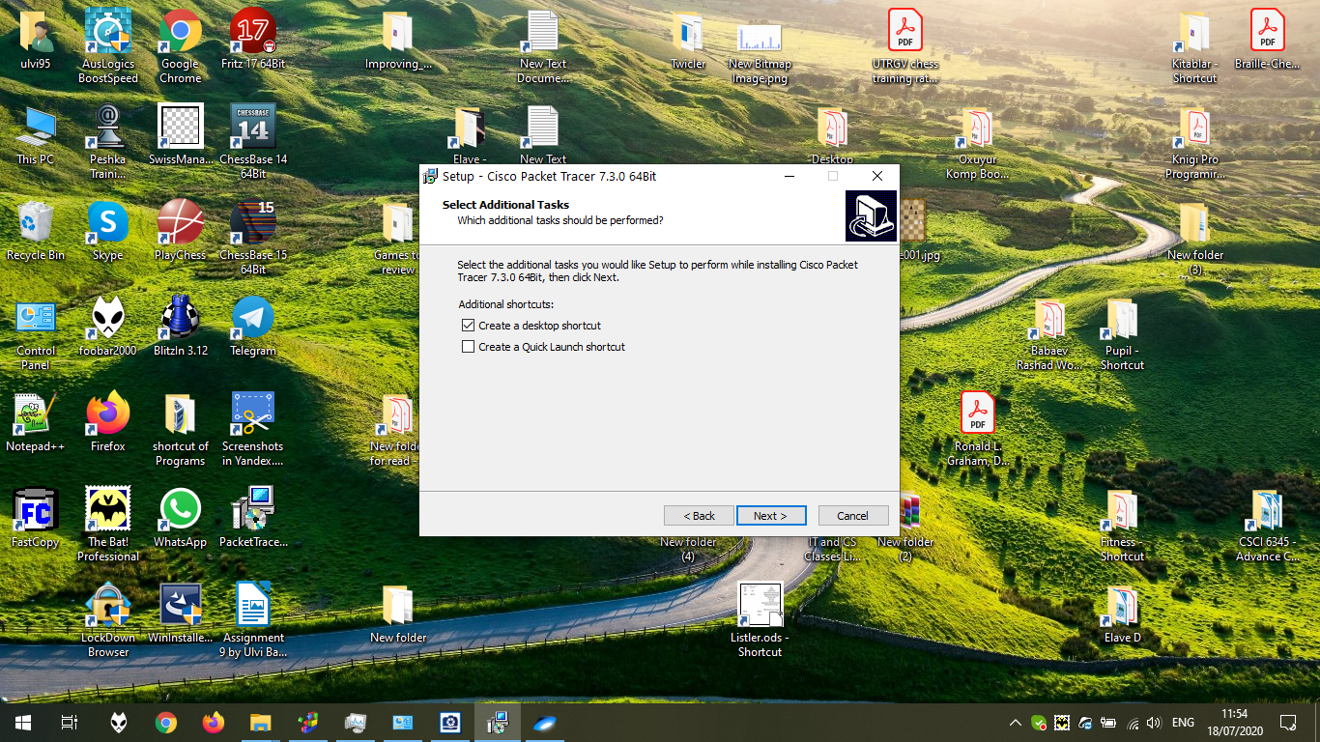

After reviewing, click “Next”

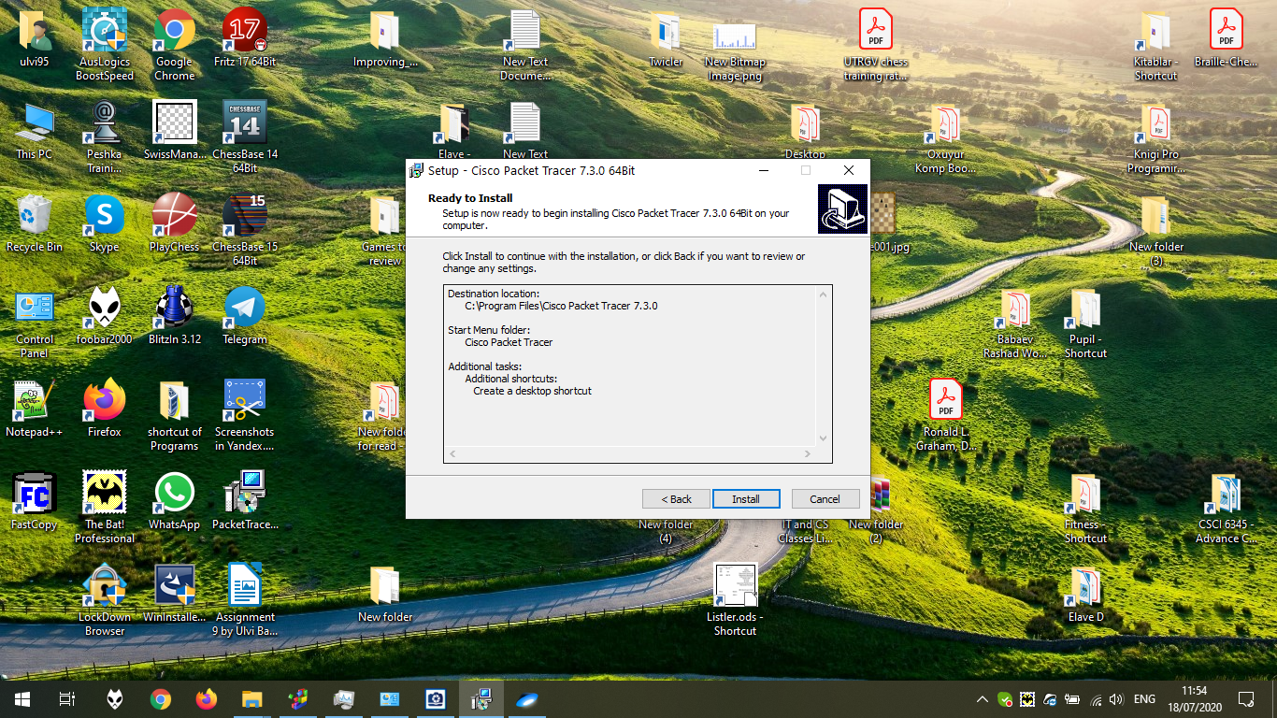

The installation process in the progress:

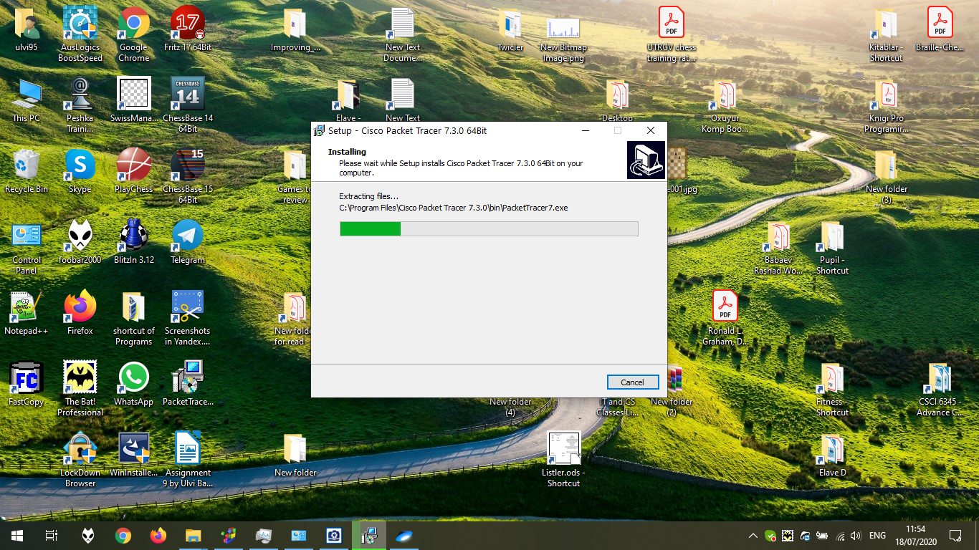

The process is finished. Let’s launch the file by clicking “Finish”:

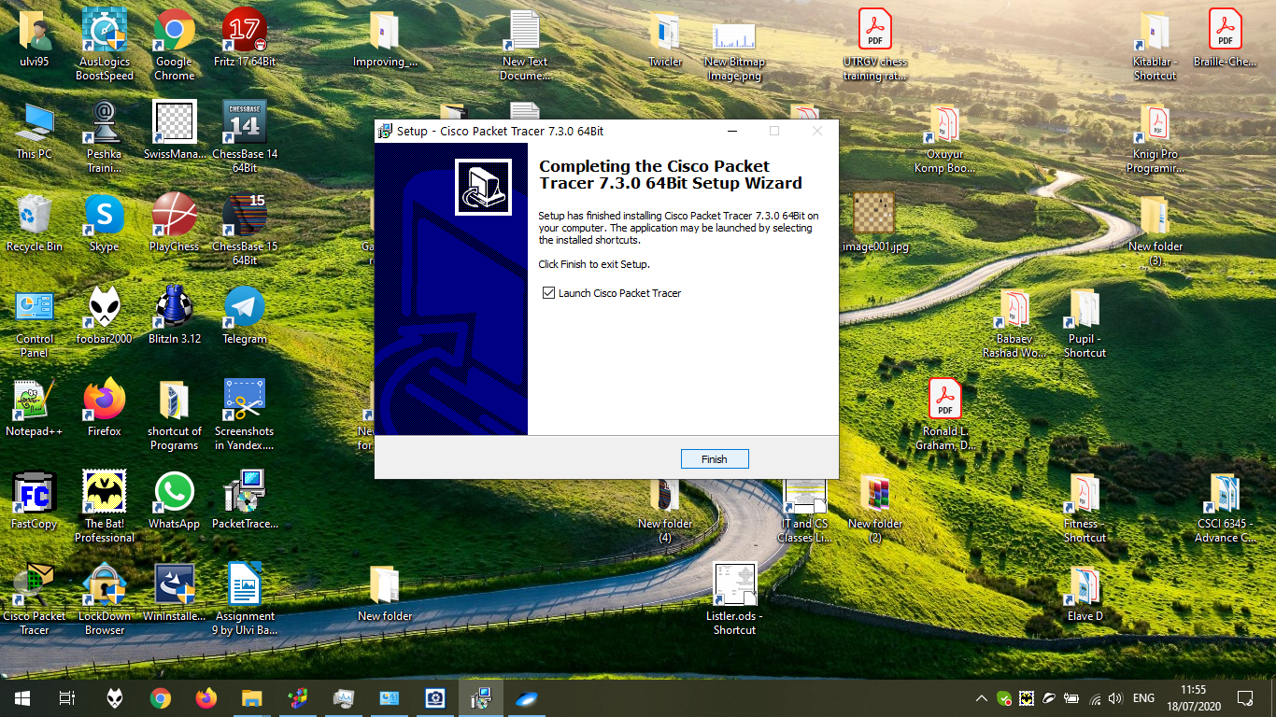

We can use the program as the guest. But using as the user allows to use all features. Write our e-mail and click Next:

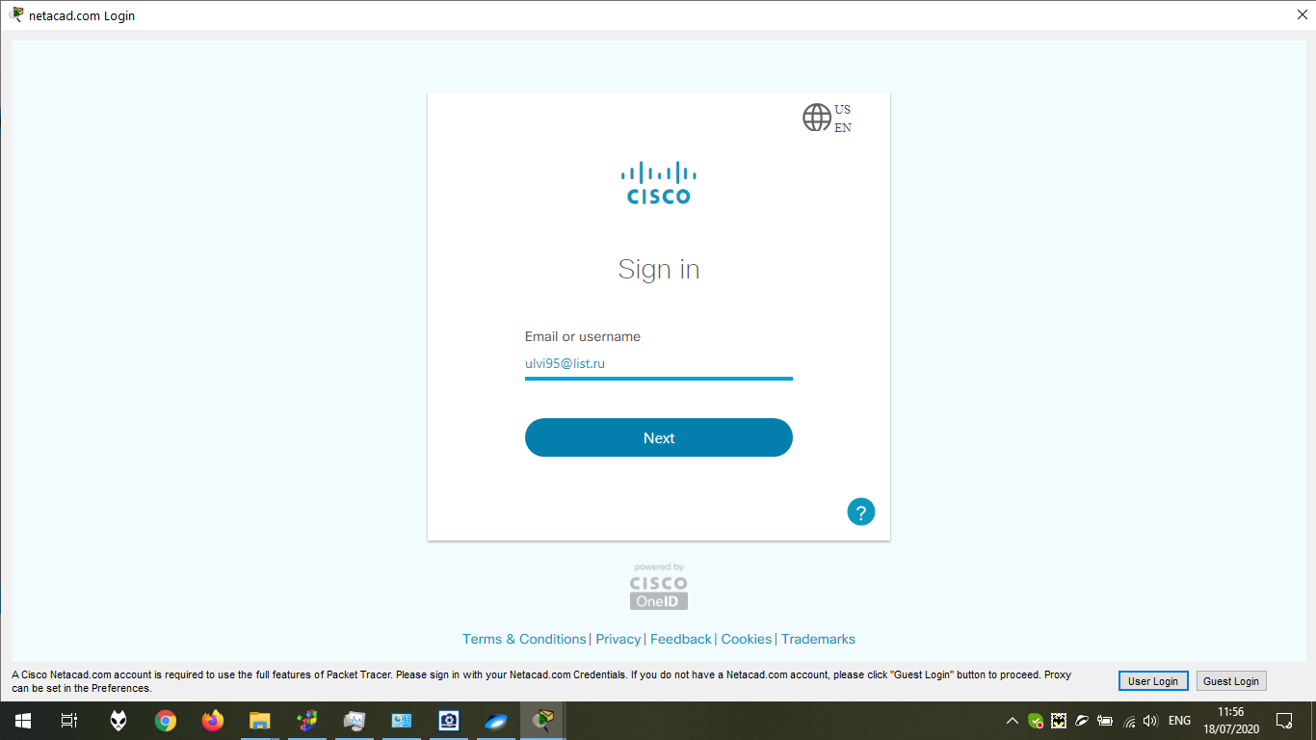

Write our password and click “Sign In”:

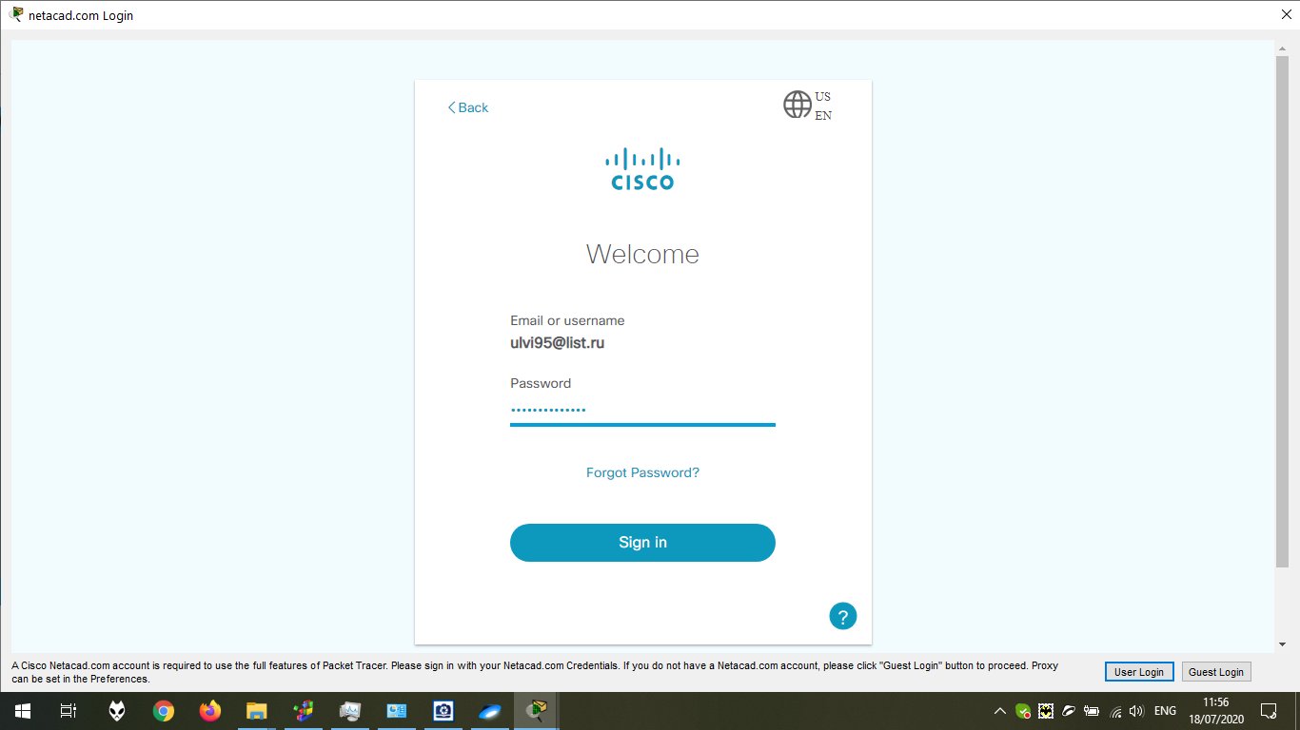

Now, we are in the program.

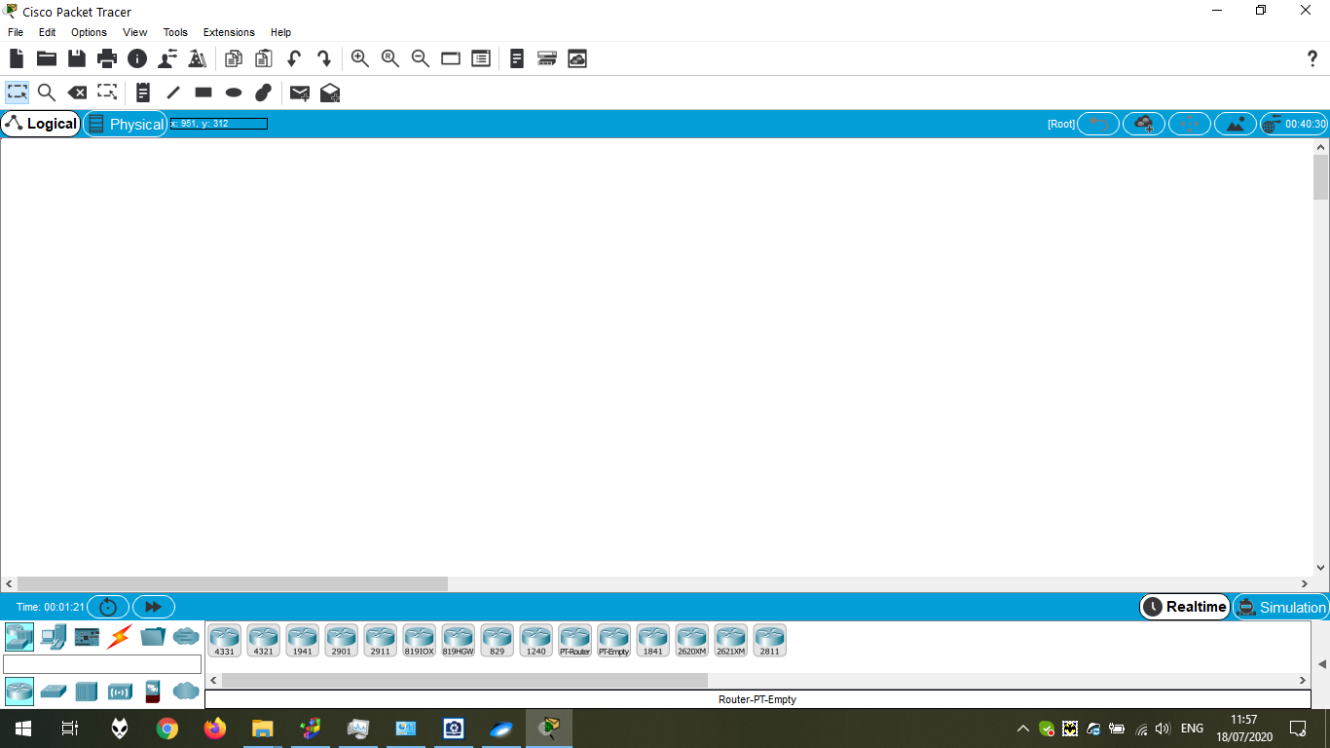

Chapter 1.2.1.1 Preview

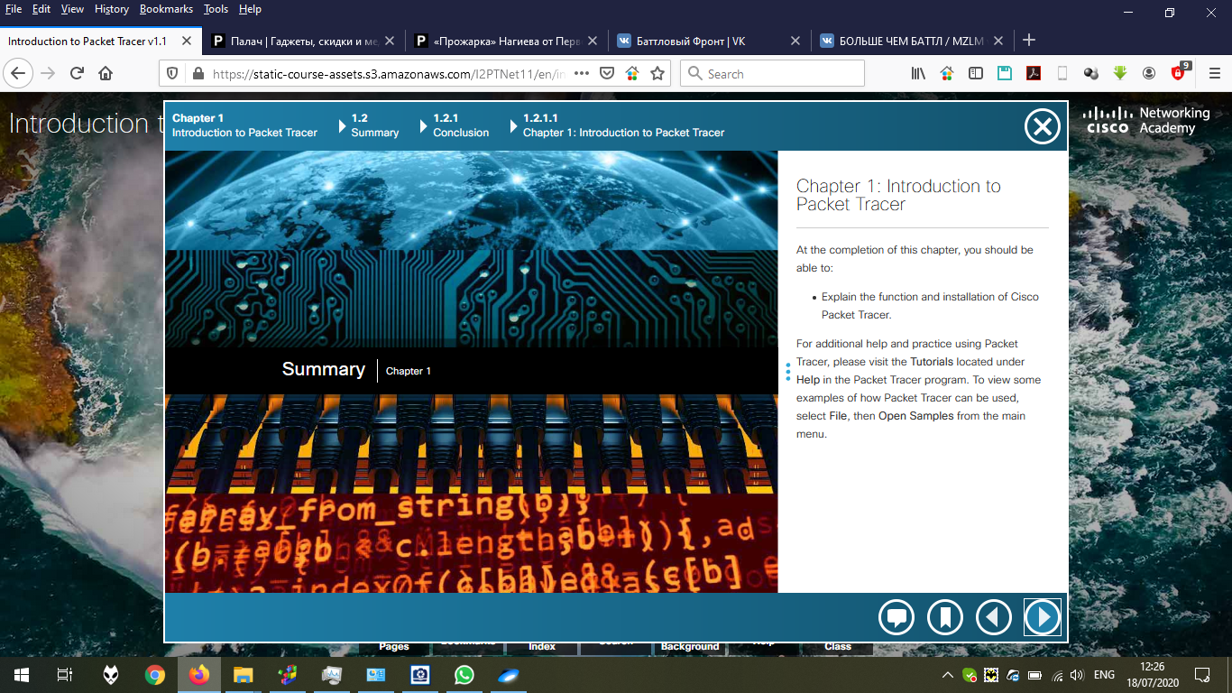

Chapter 2.0.1.1 Preview

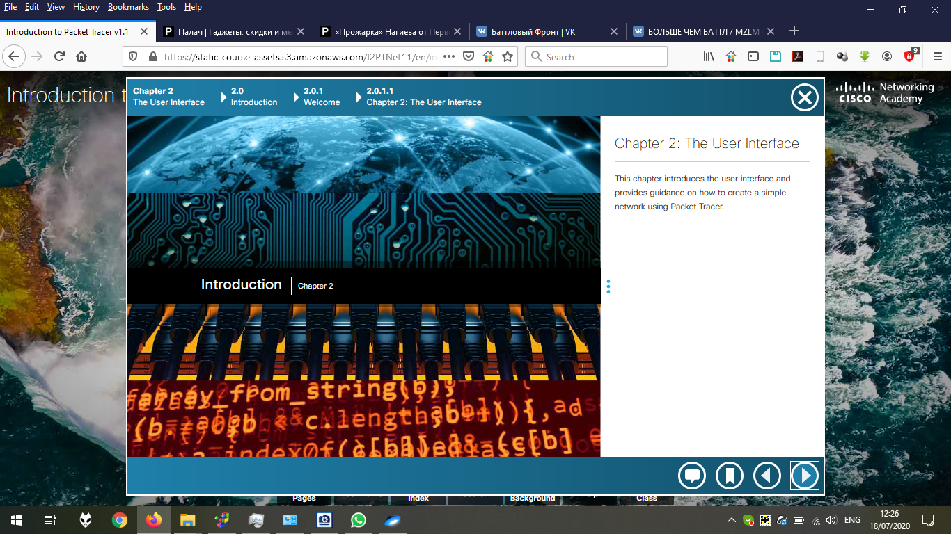

Chapter 2.1.1.1 Preview

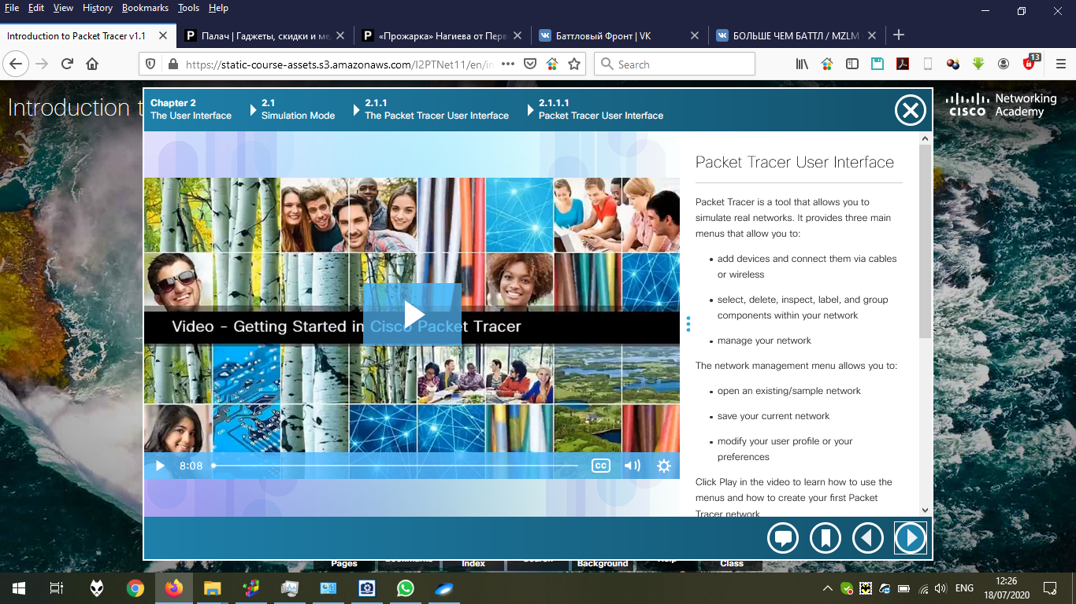

When we open the program, Logical View is the default view. The quick view of Network Devices below.

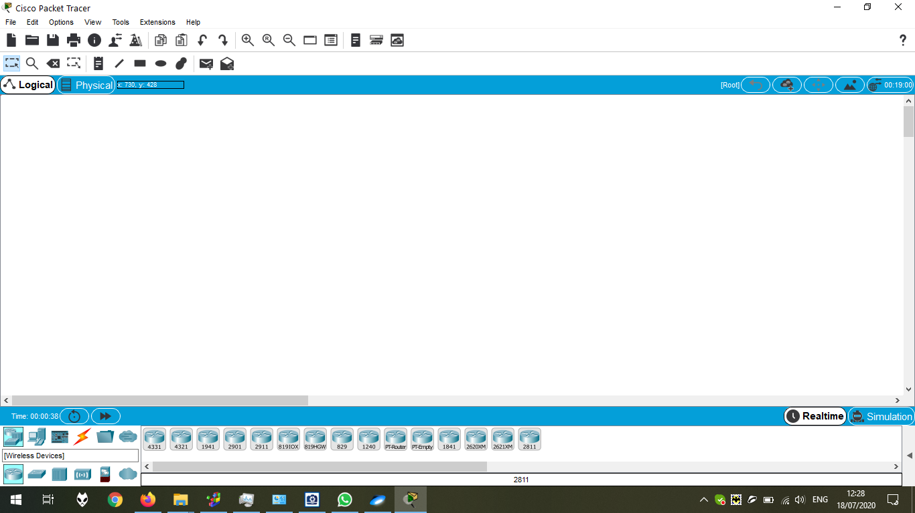

The quick view of End Devices:

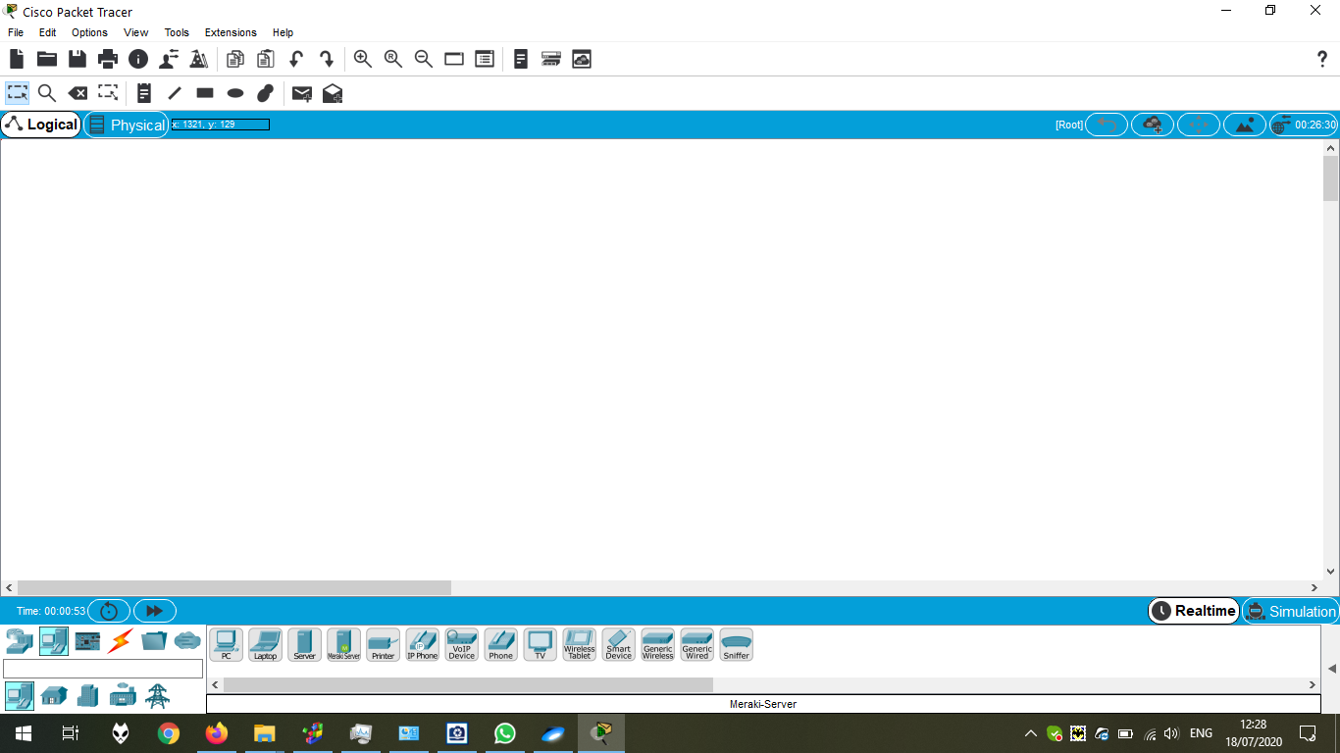

The quick view of Components:

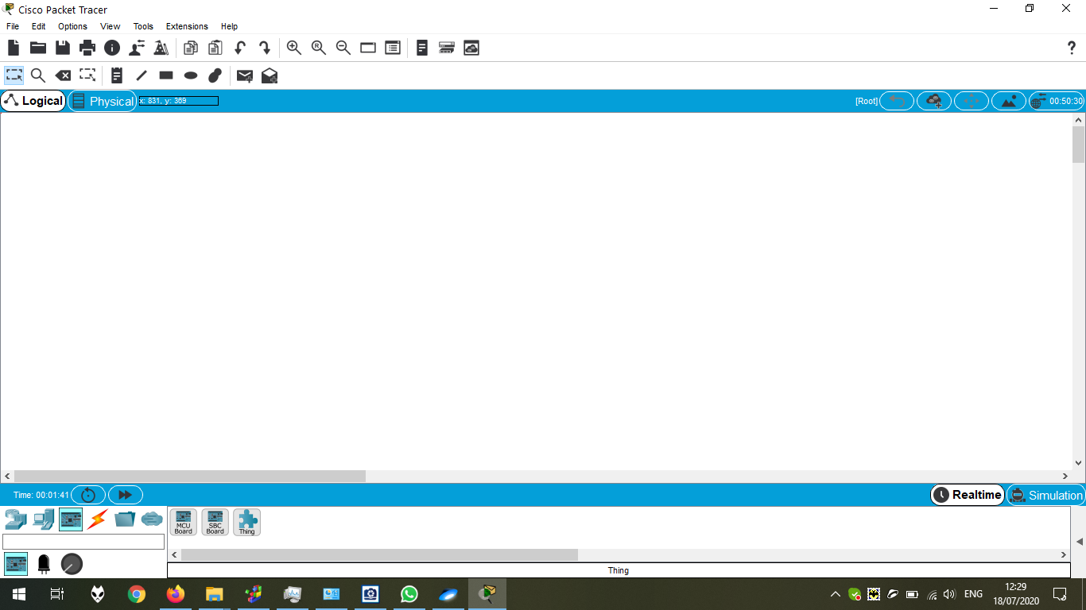

The quick view of Connections:

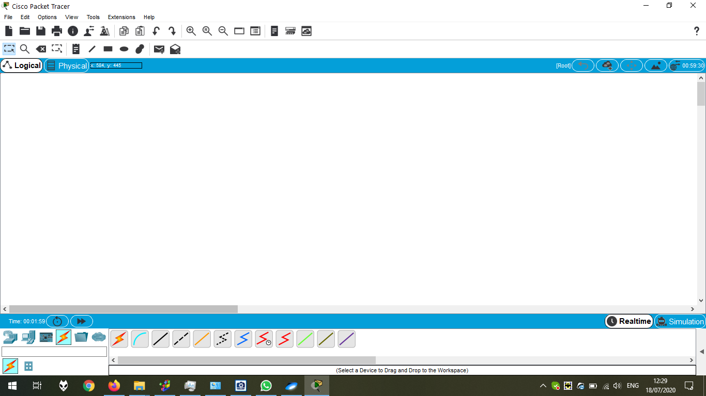

The quick view of Miscellaneous:

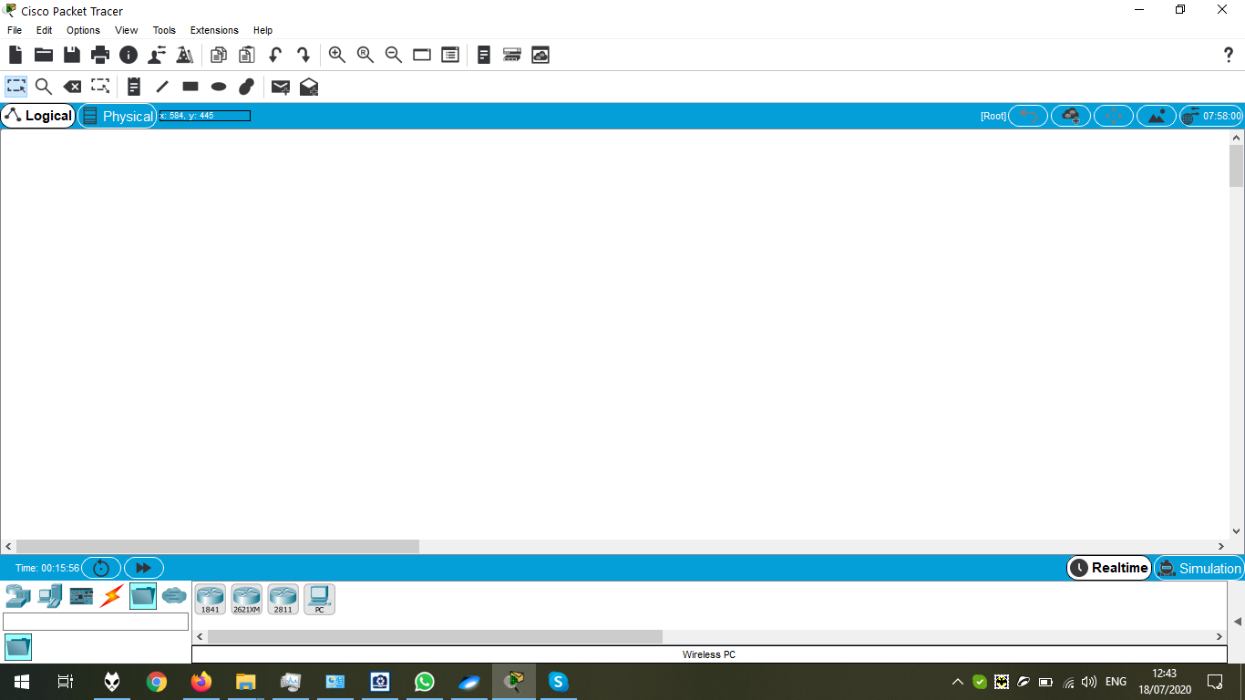

The quick view of Multiuser Connection:

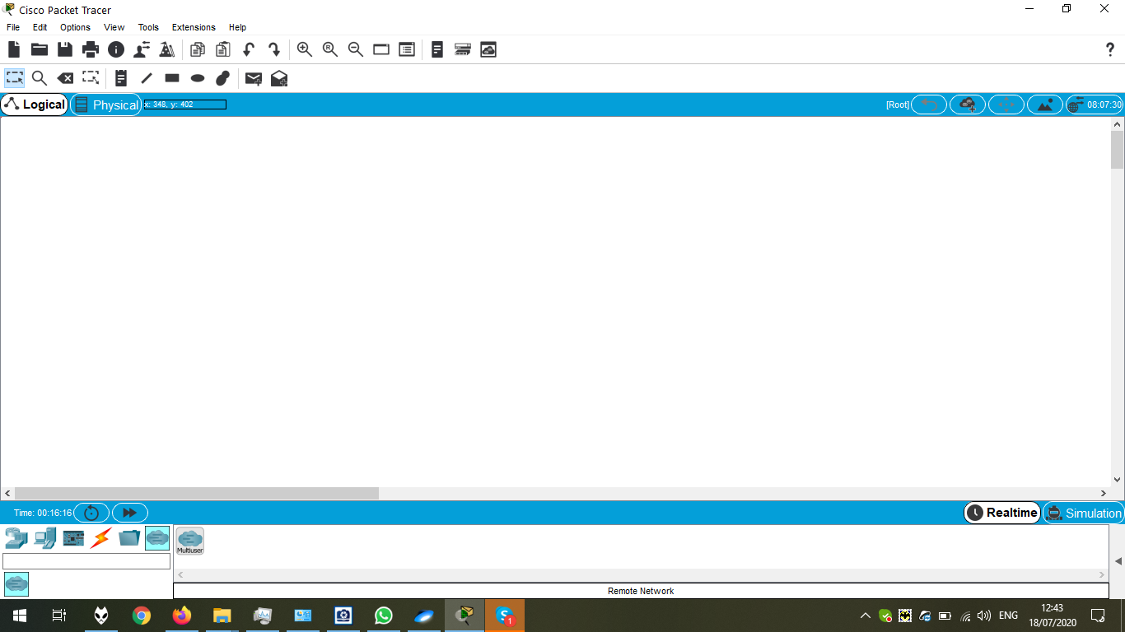

The quick view of Draw Line Option:

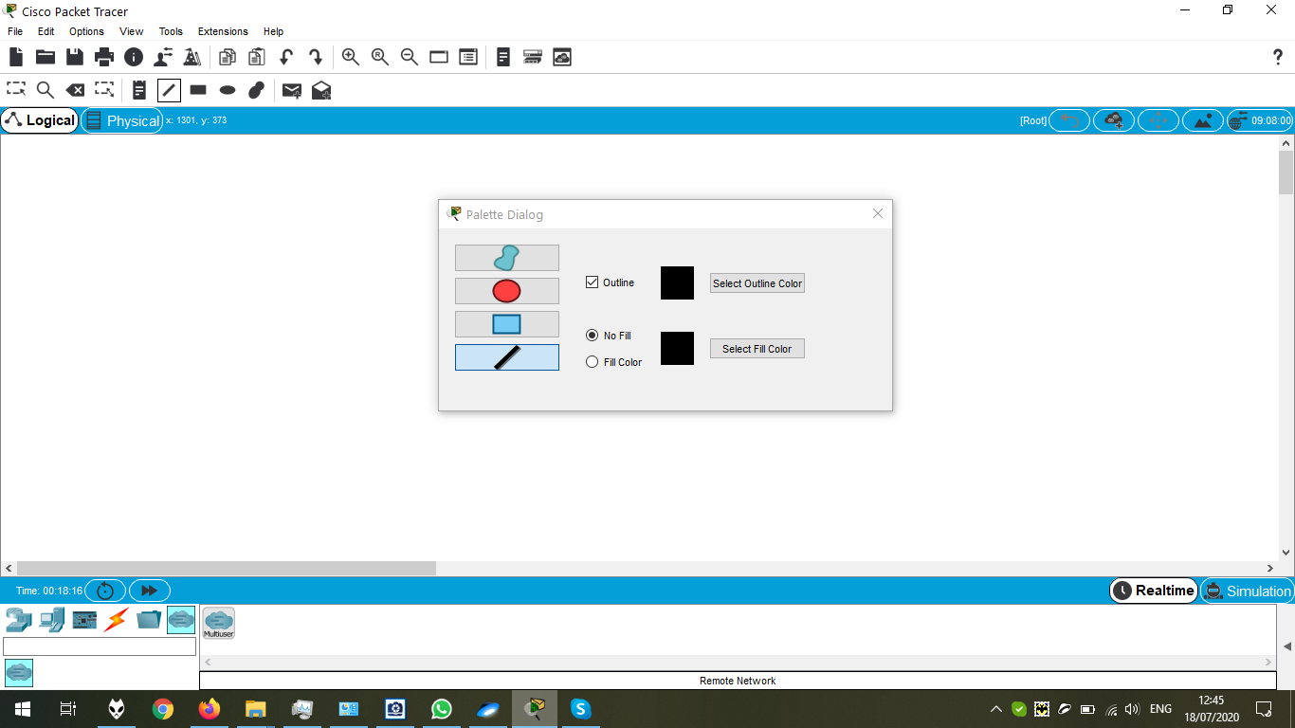

Opening some file and viewing some connection:

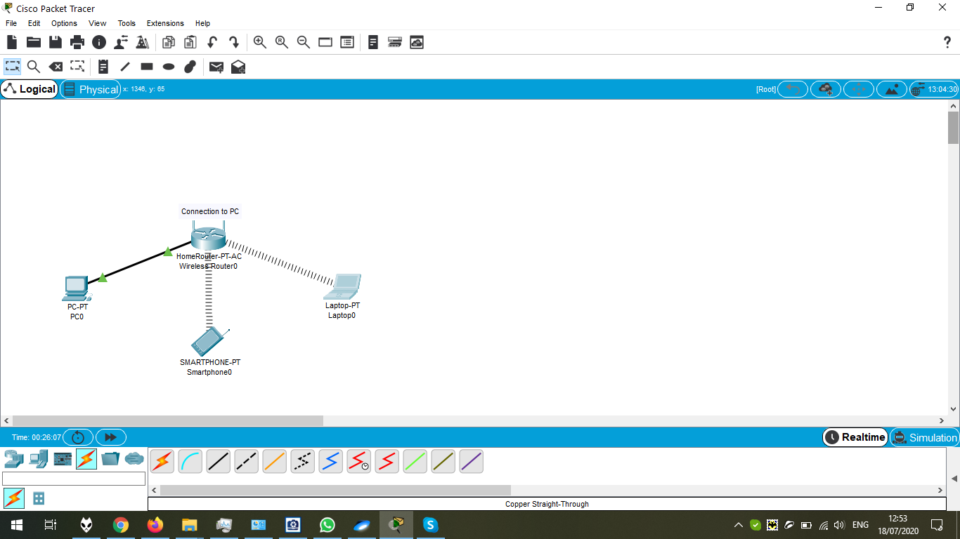

Deleting the connection by Delete Button (is already pressed).

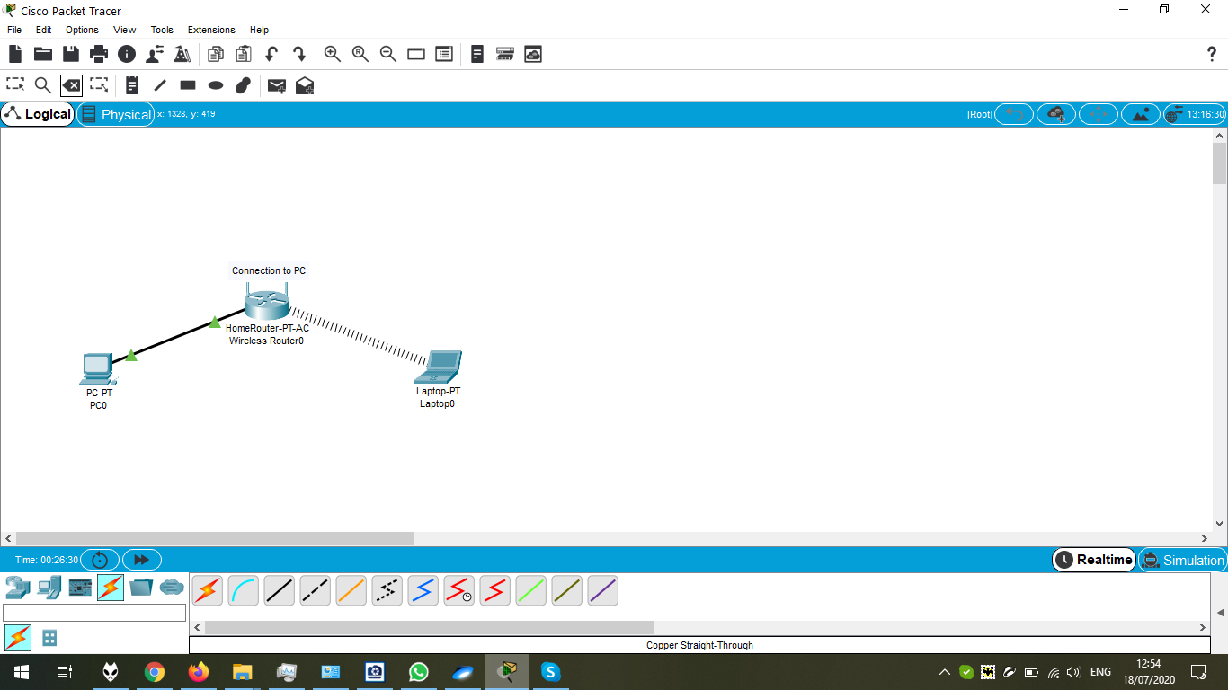

Chapter 2.1.1.2 Preview

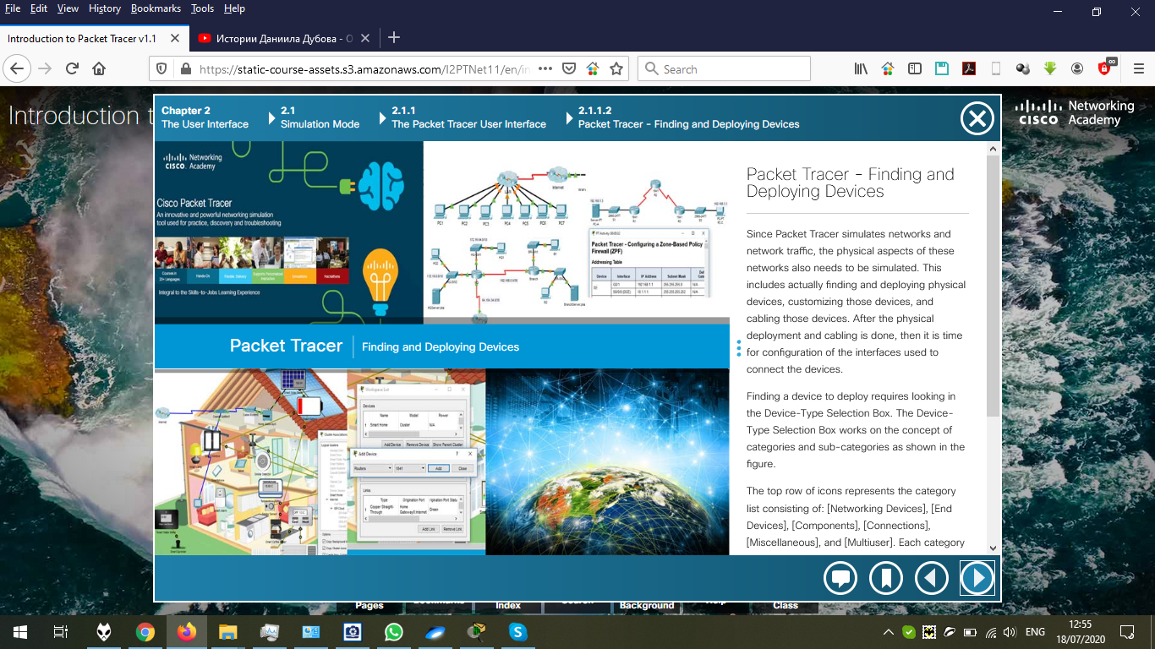

The PDF “Deploying Devices”:

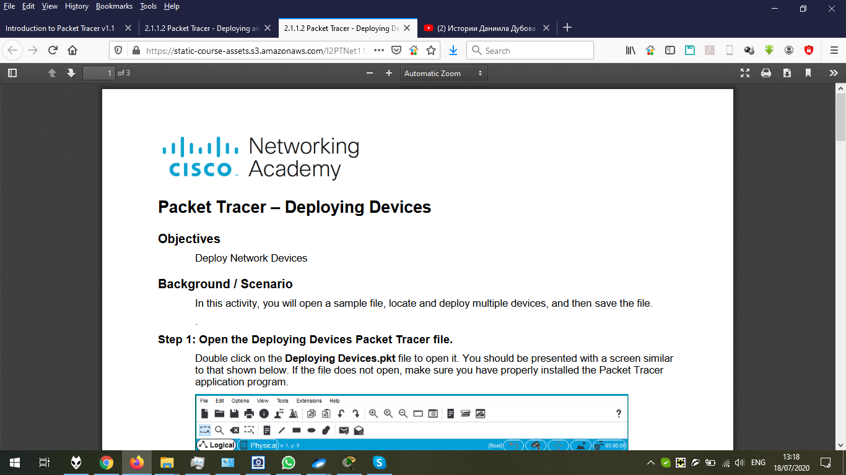

The PDF “Deploying and Cabling Devices”:

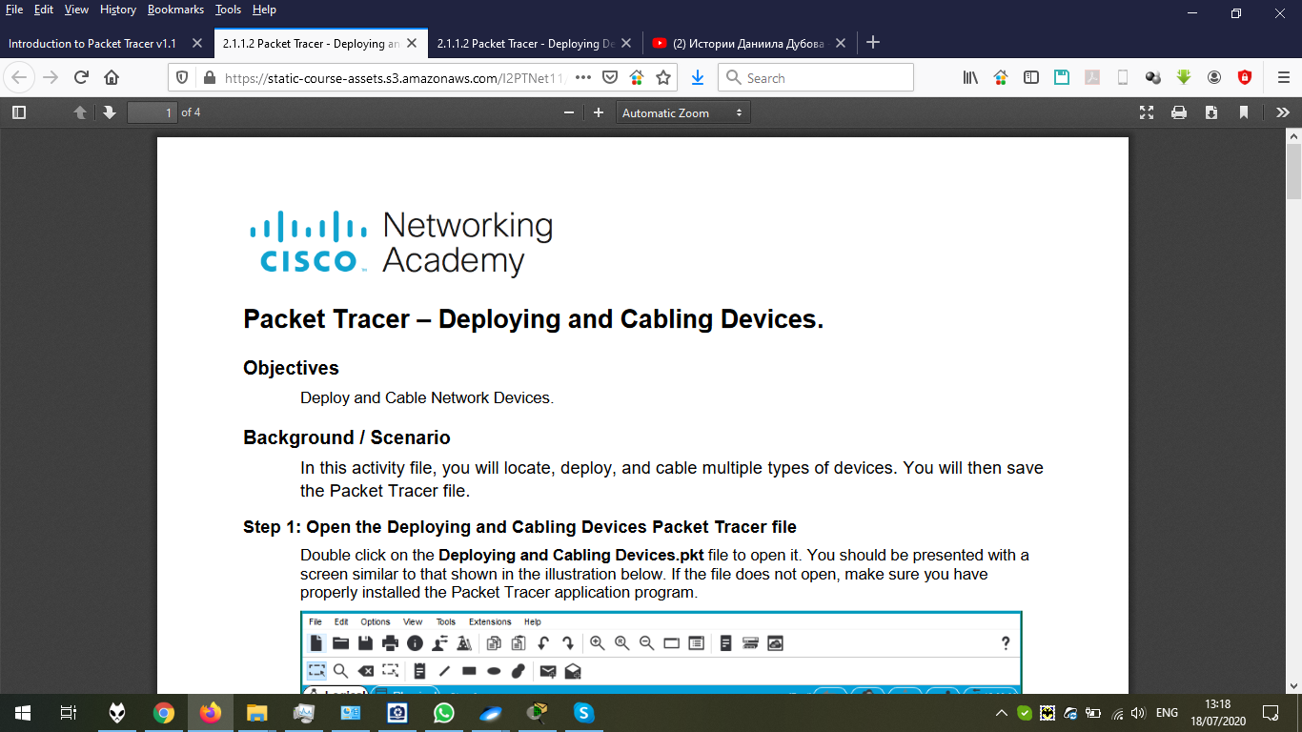

Opening the file:

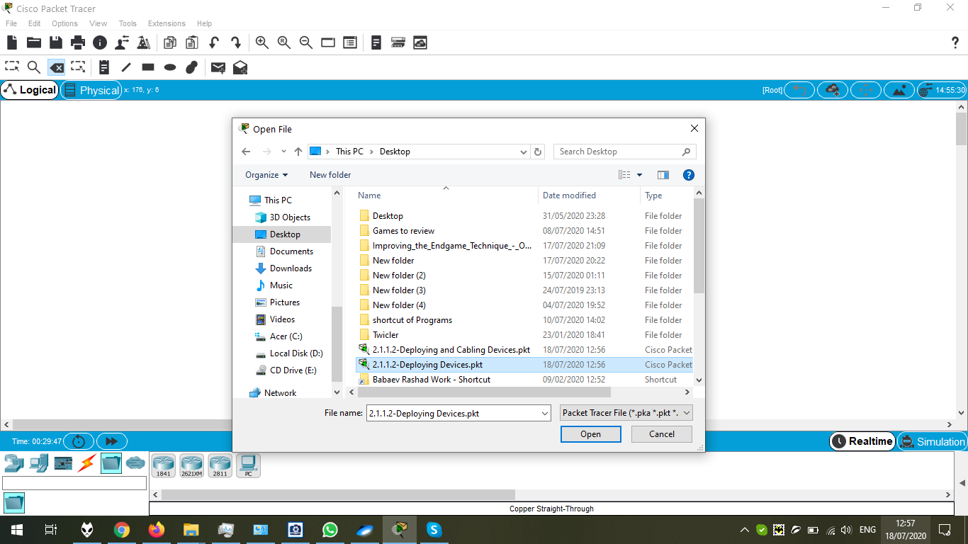

The scratch to do:

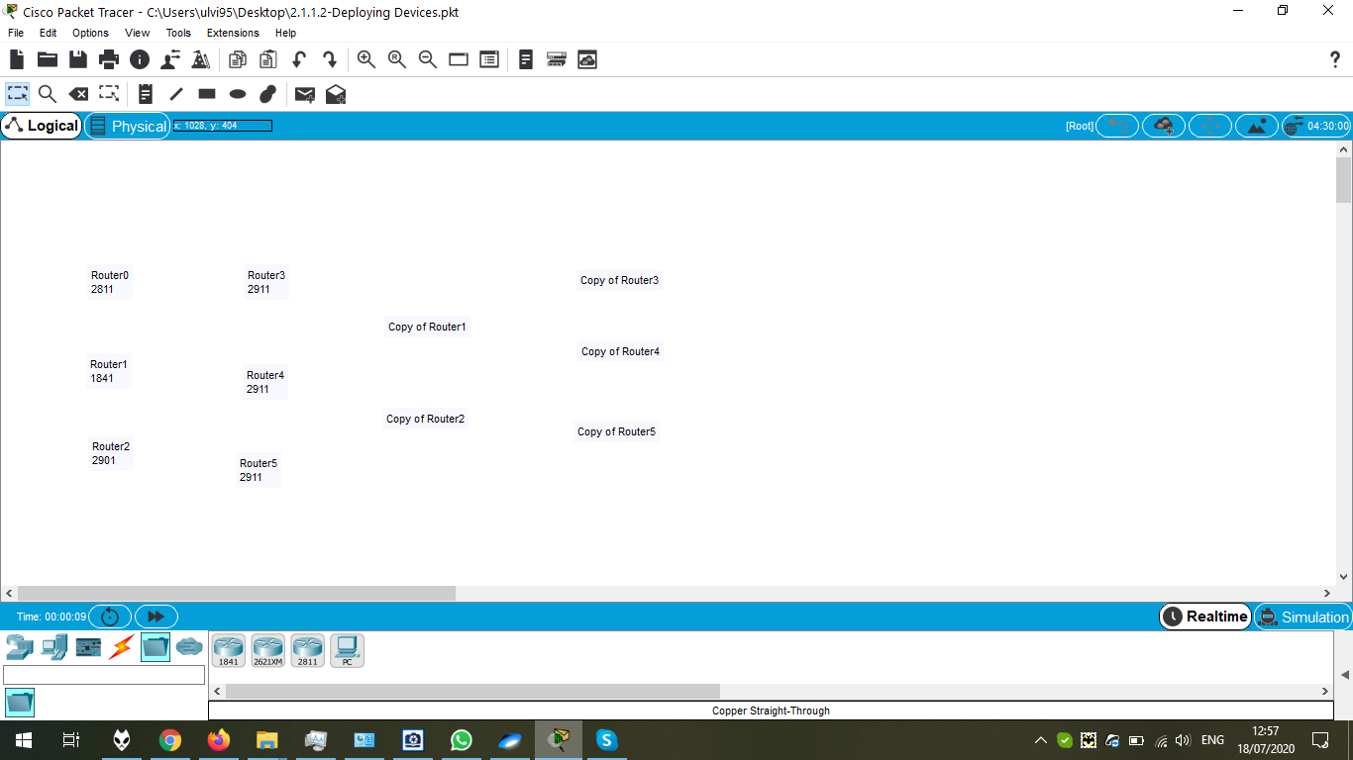

The final result:

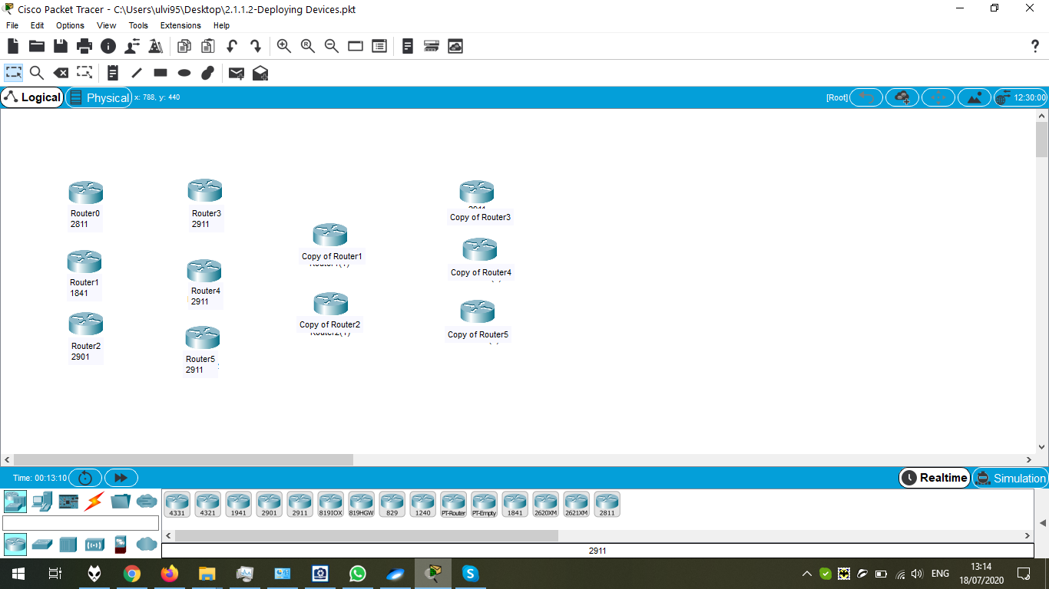

Saving the file:

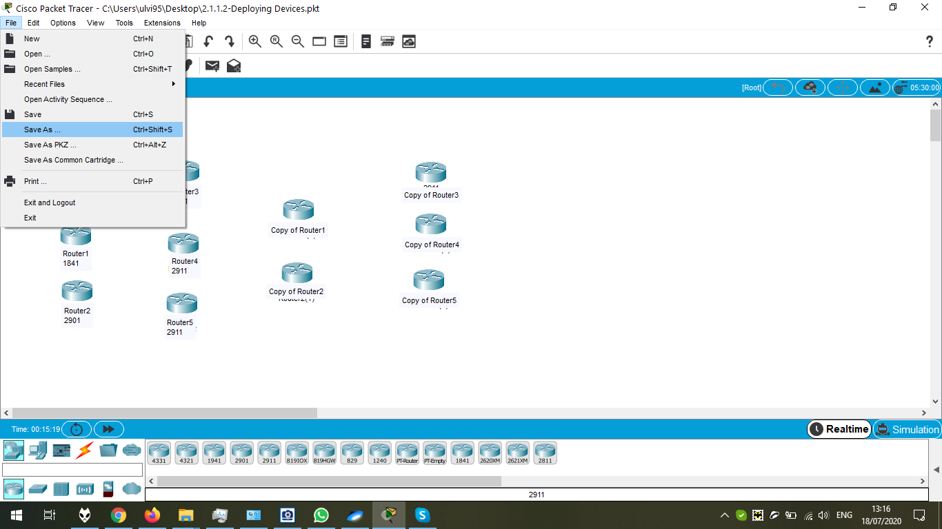

Defining the file name.

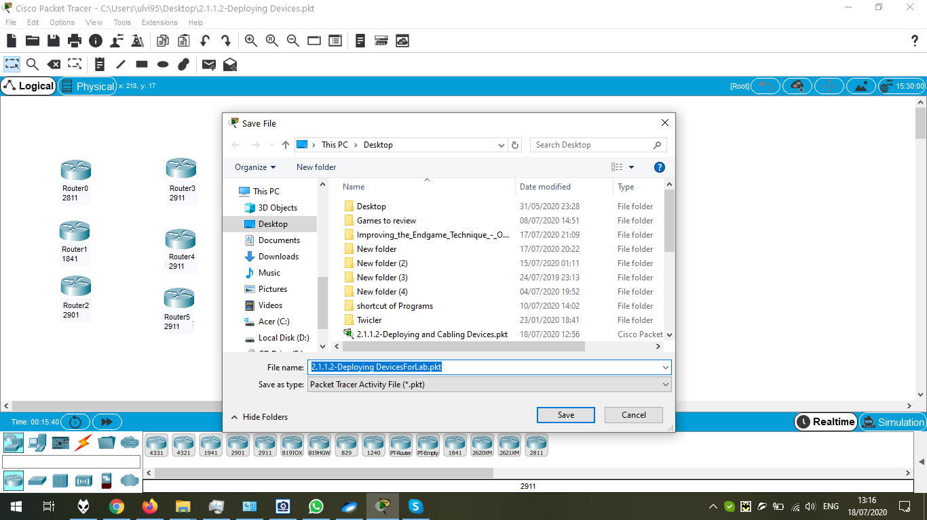

After opening another file and proper cabling:

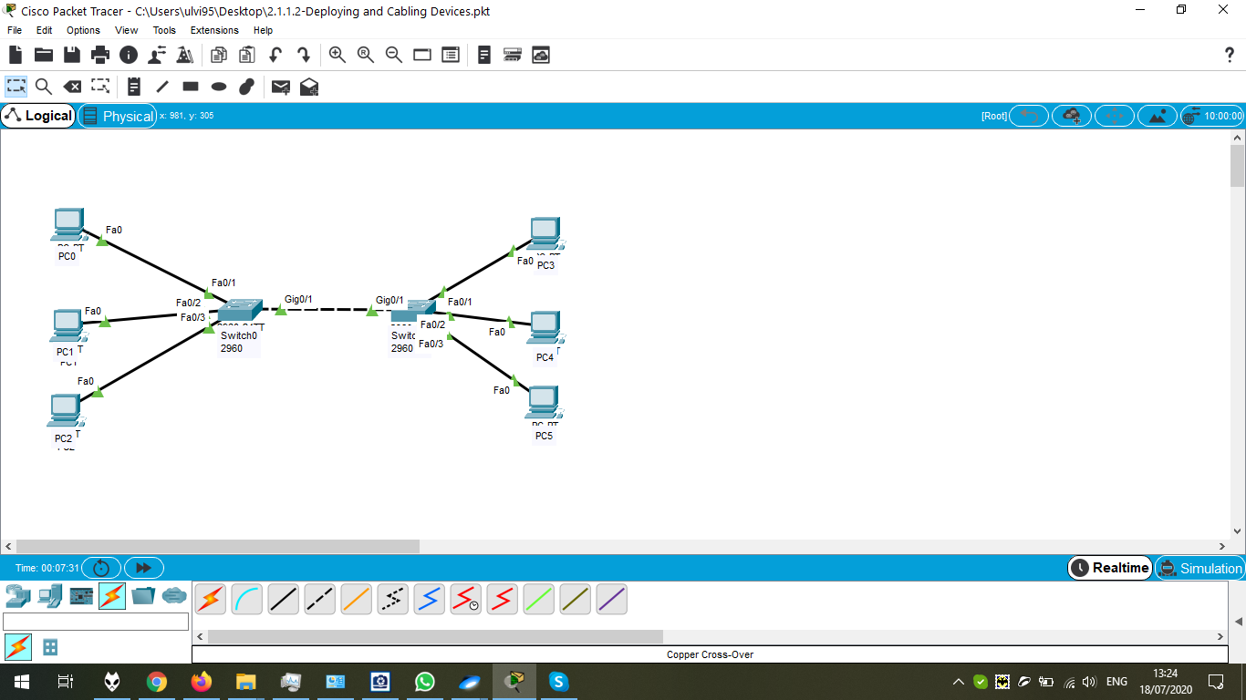

Saving the file:

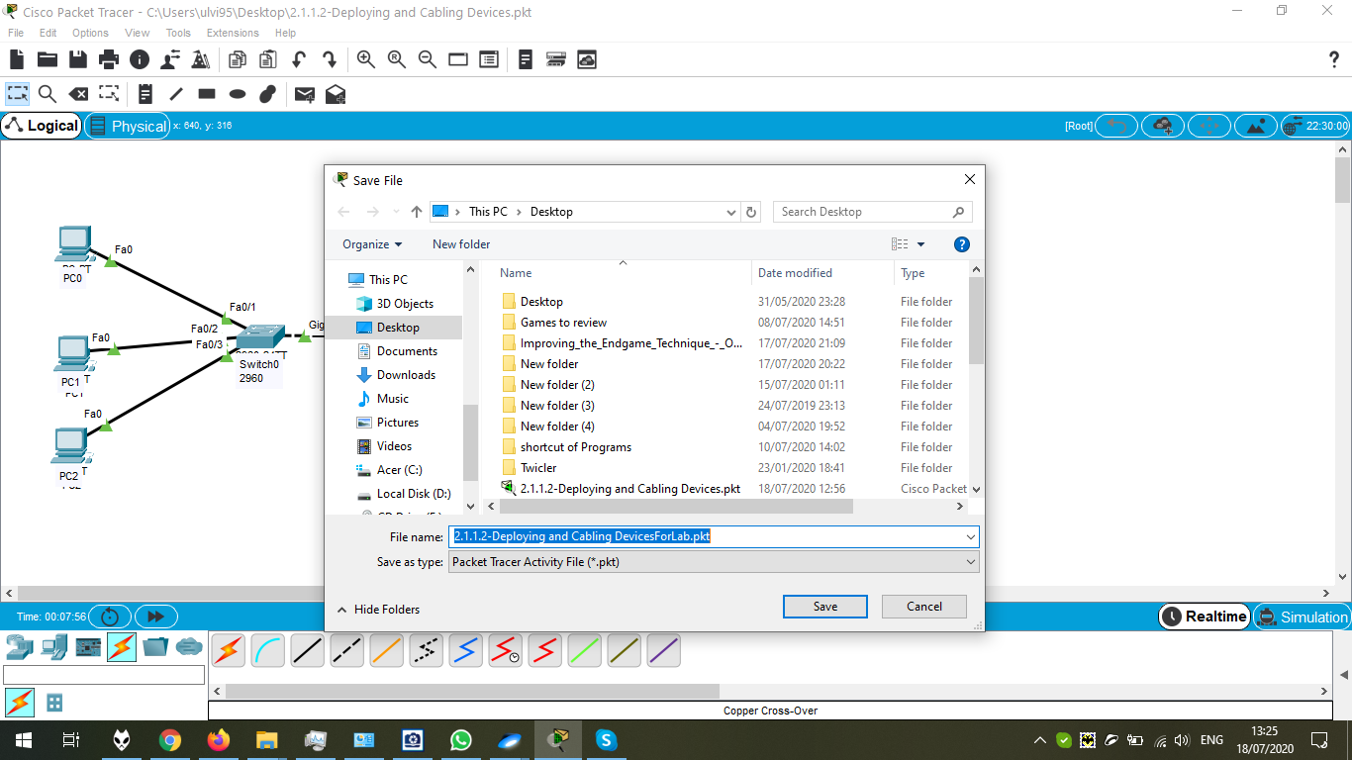

Chapter 2.1.1.3 Preview

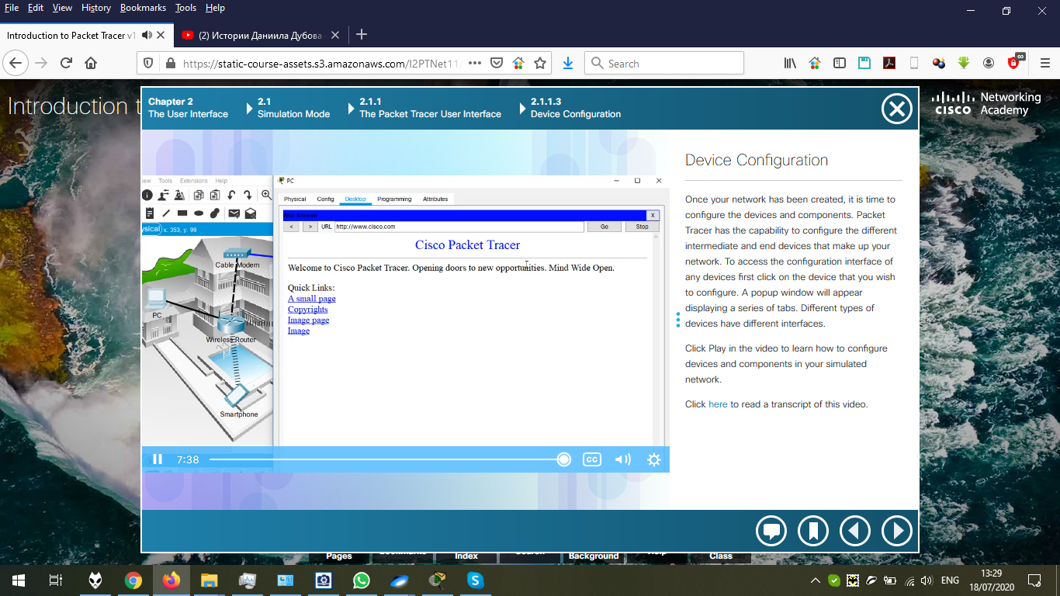

Desktop options (in the screenshot, for Server0):

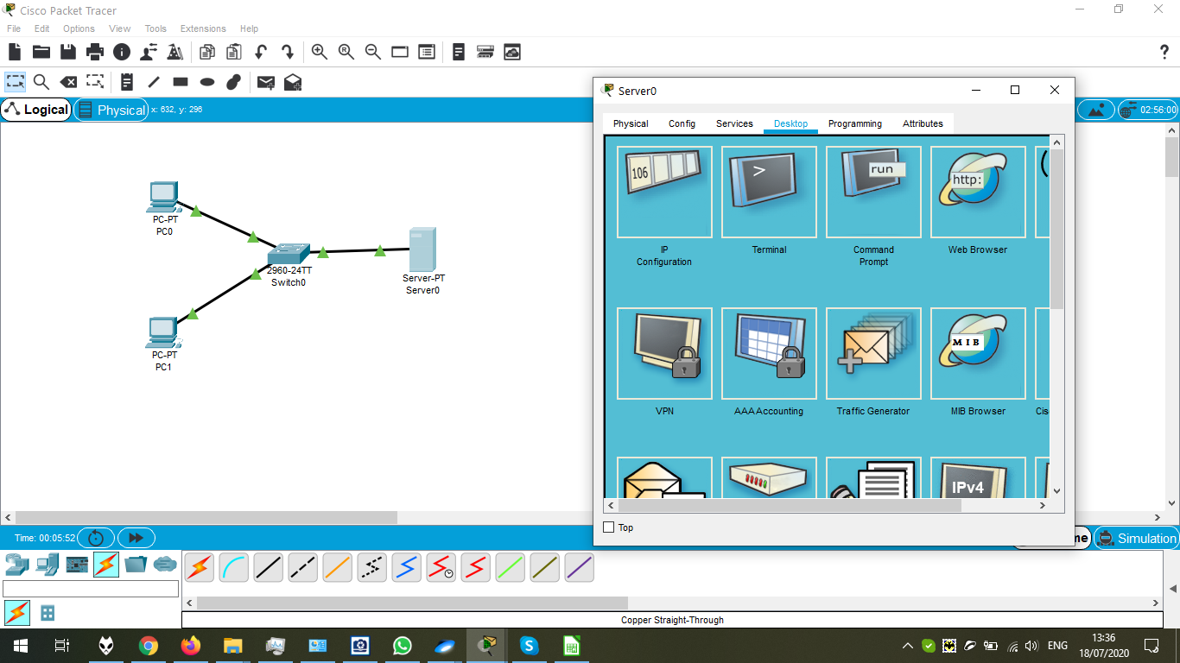

Defining IP Configuration for Server:

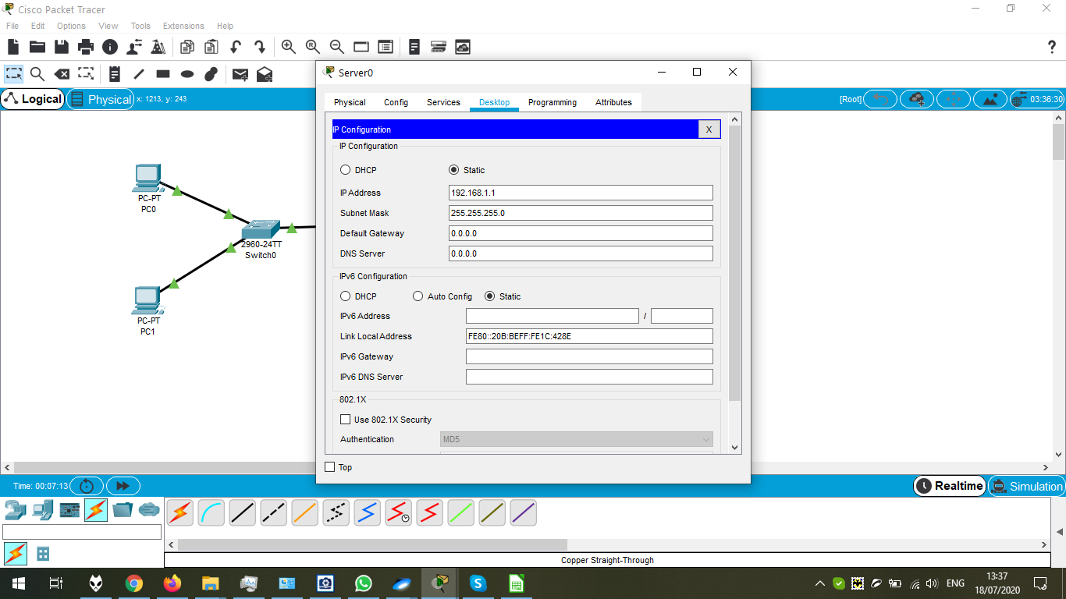

Defining IP Configuration for PC0:

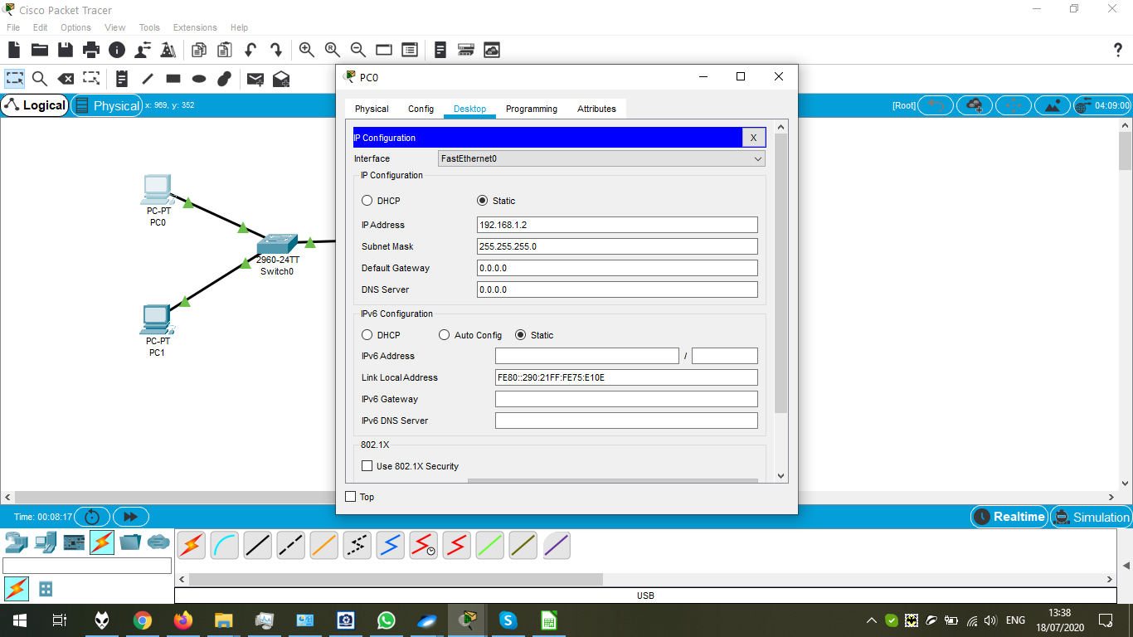

Pinging PC0:

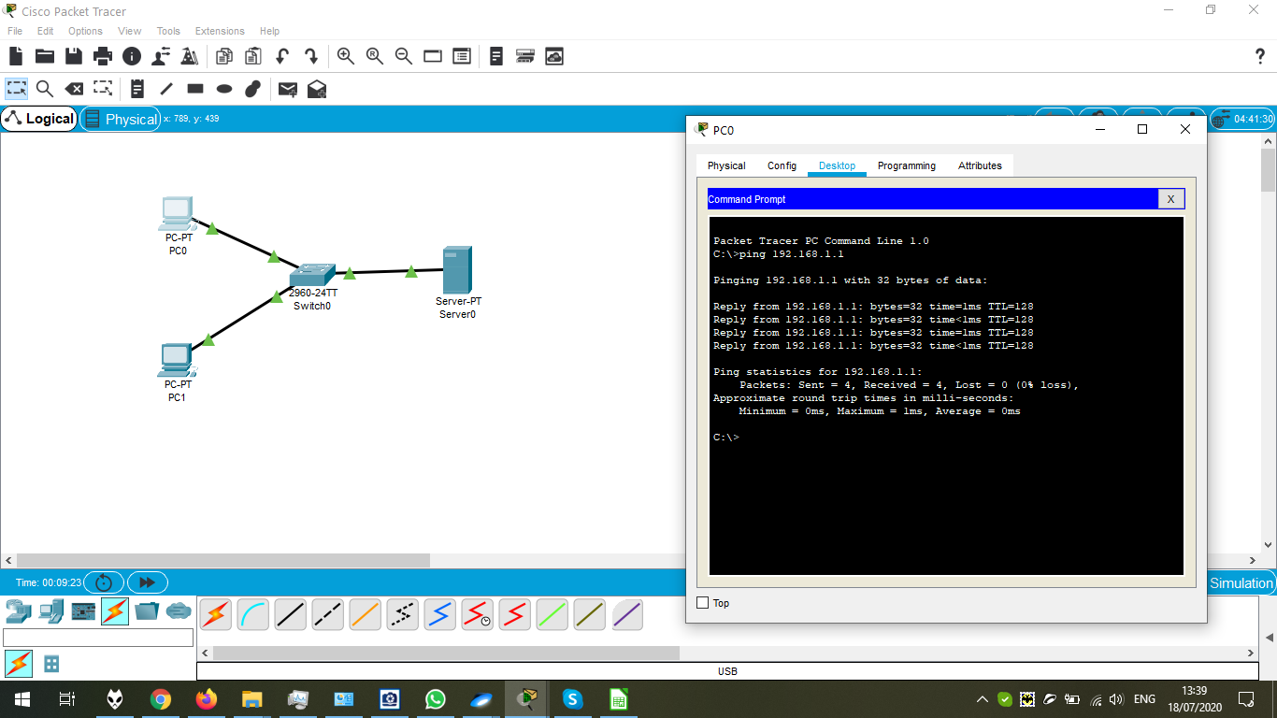

Configuration of PC1:

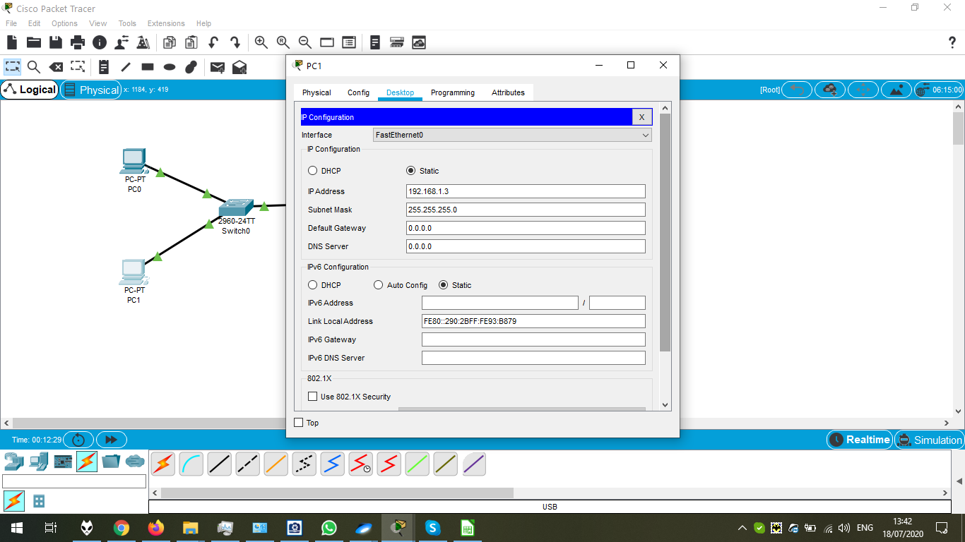

Pinging PC1 after the same configuring operations:

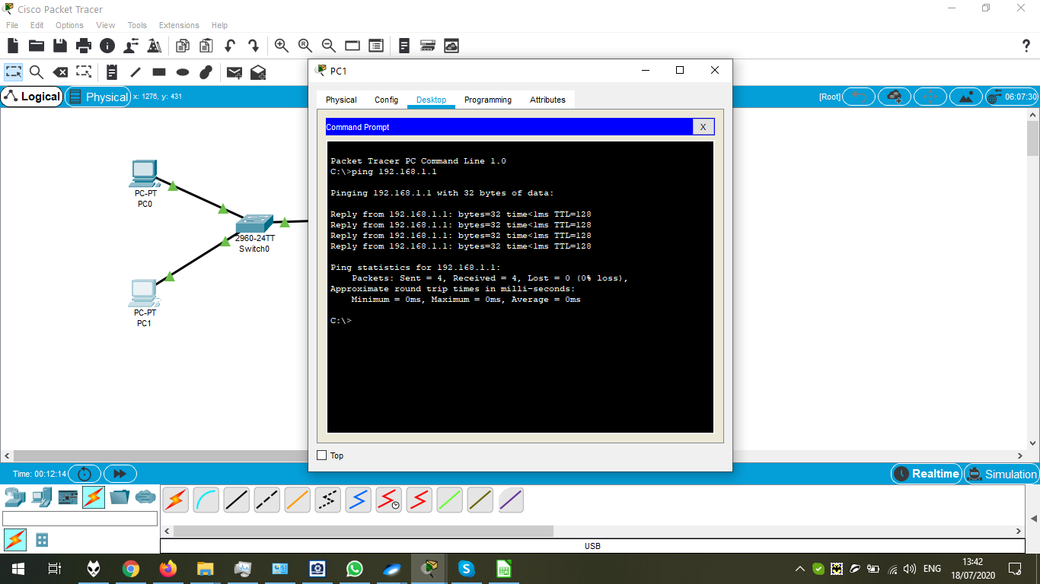

Testing PC1 for the IP:

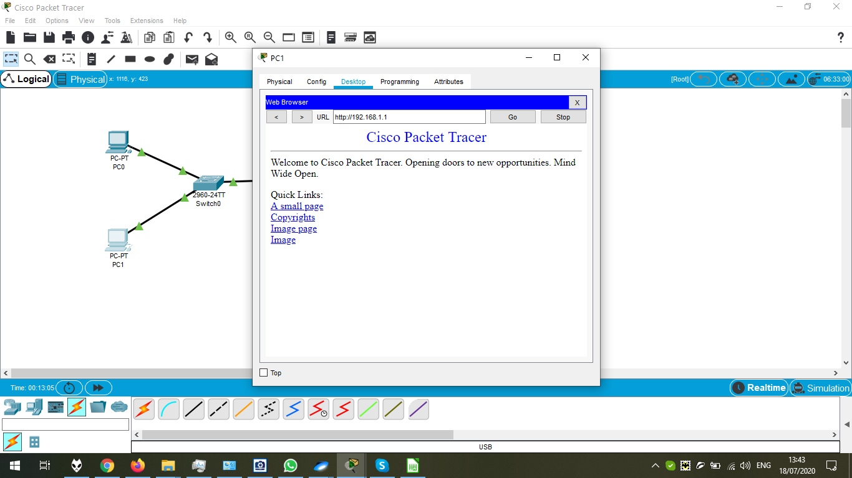

Configuration of the Switch:

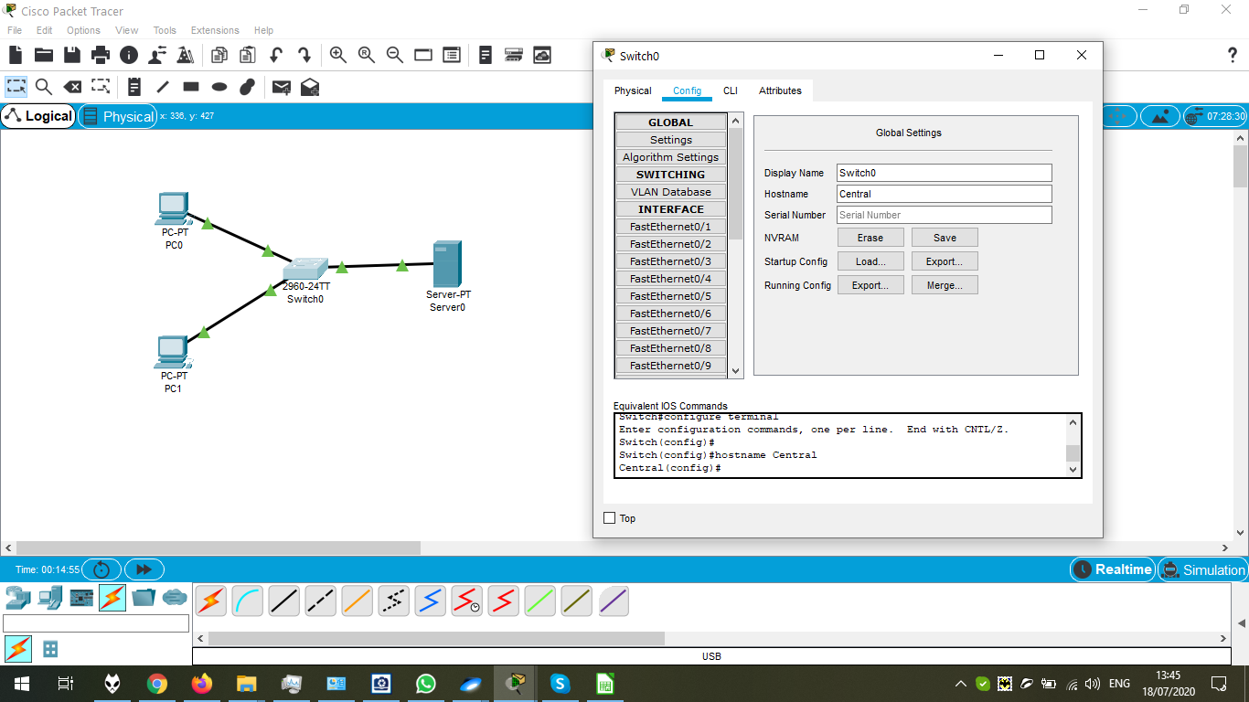

CLI Options: Here, the device is shut down for PC0:

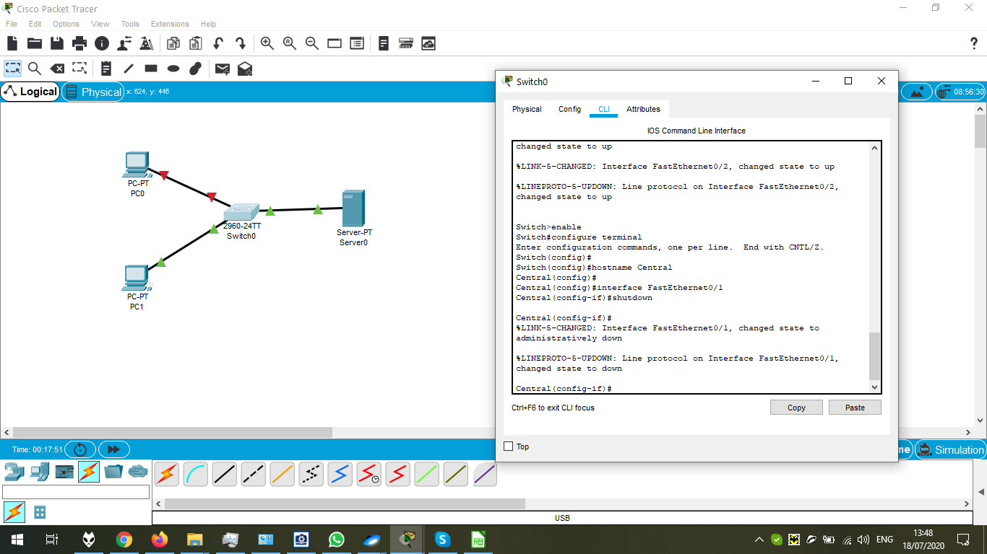

PDF “Packet Tracer – Create a Simple Network Using Packet Tracer”

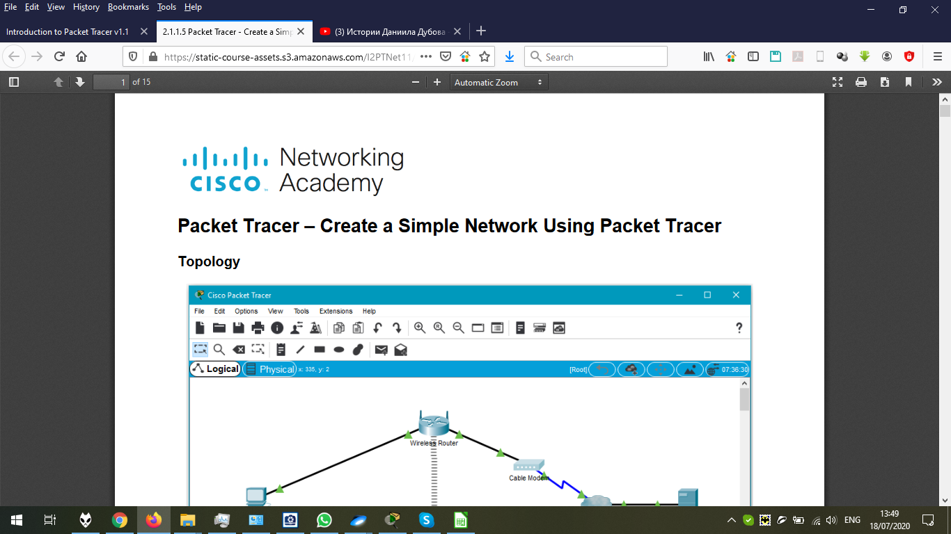

The configuration of Wireless Router – Changing the SSID:

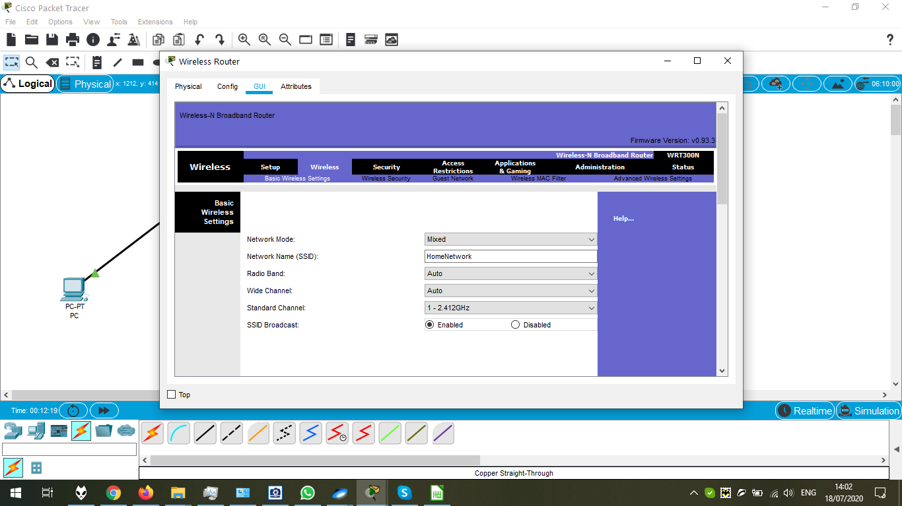

The configuration of Wireless Router – Defining the IP and DNS Server Address:

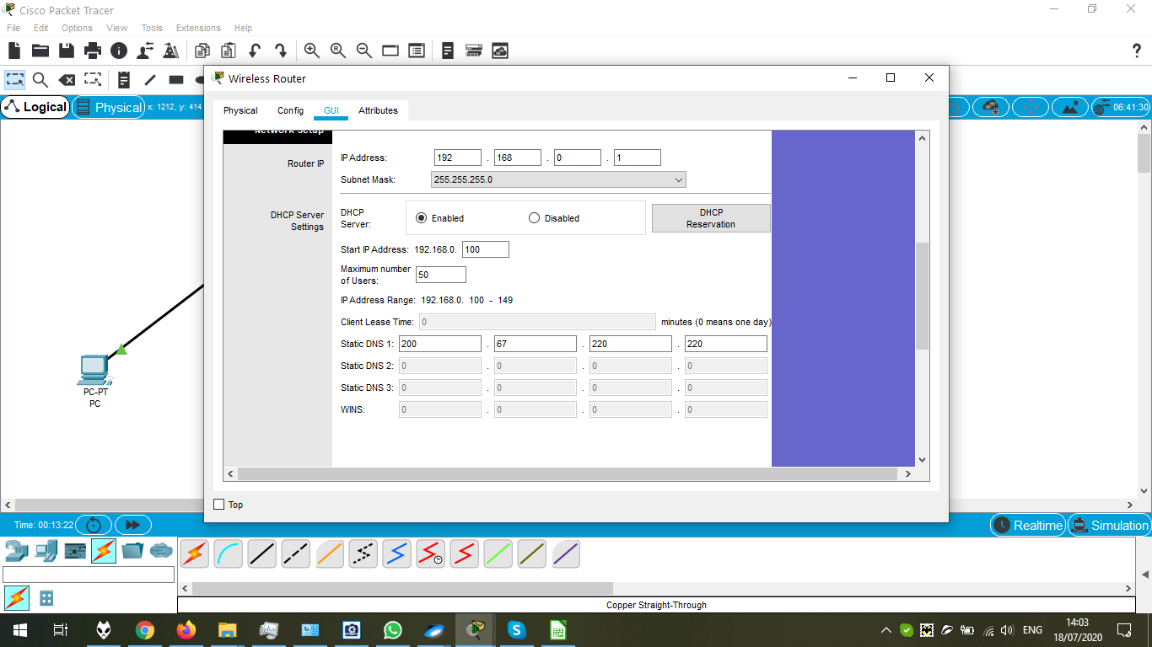

The configuration of Laptop – Adding the Wireless adapter:

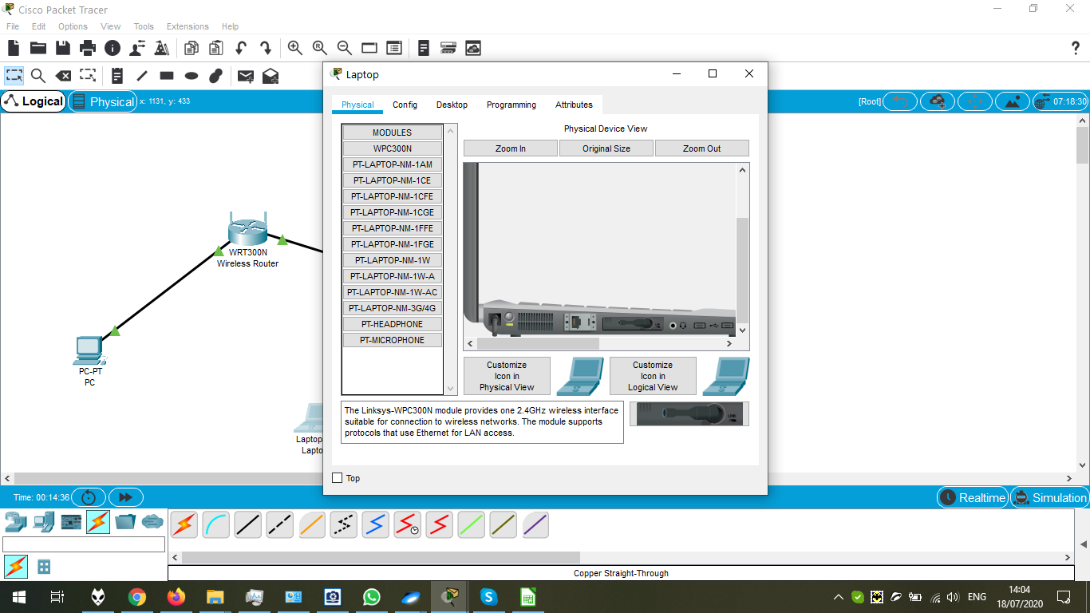

The connection options for the switch are established, now, we should configure the server for the connection:

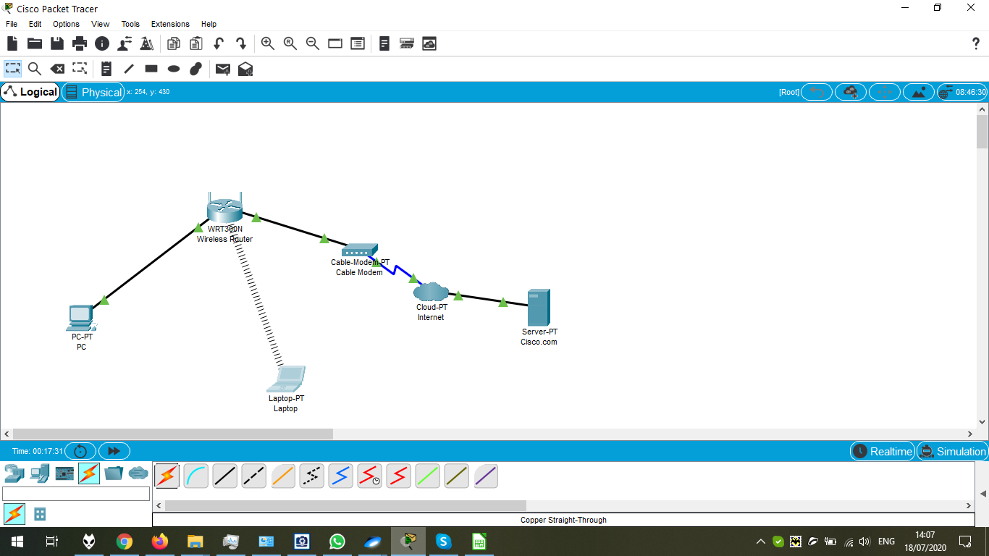

The configuration of PC:

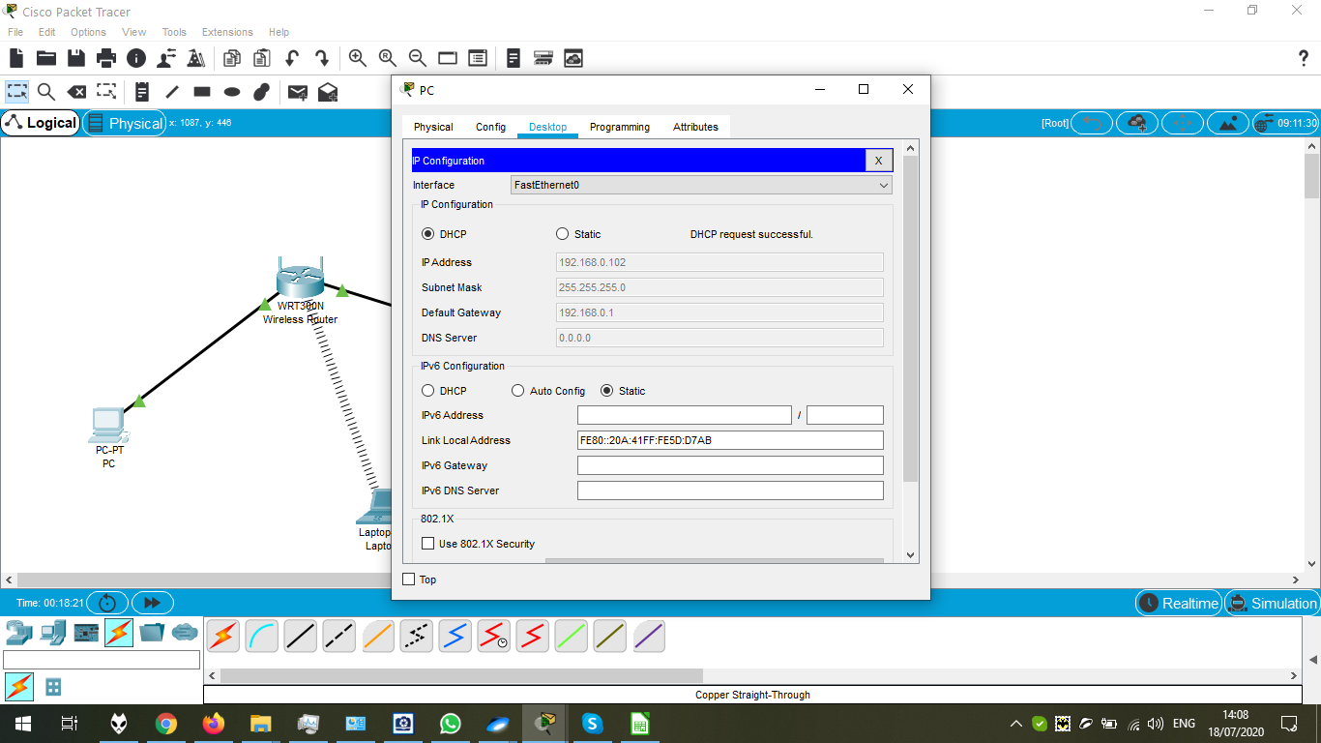

Executing of Ipconfig – there is no DNS yet:

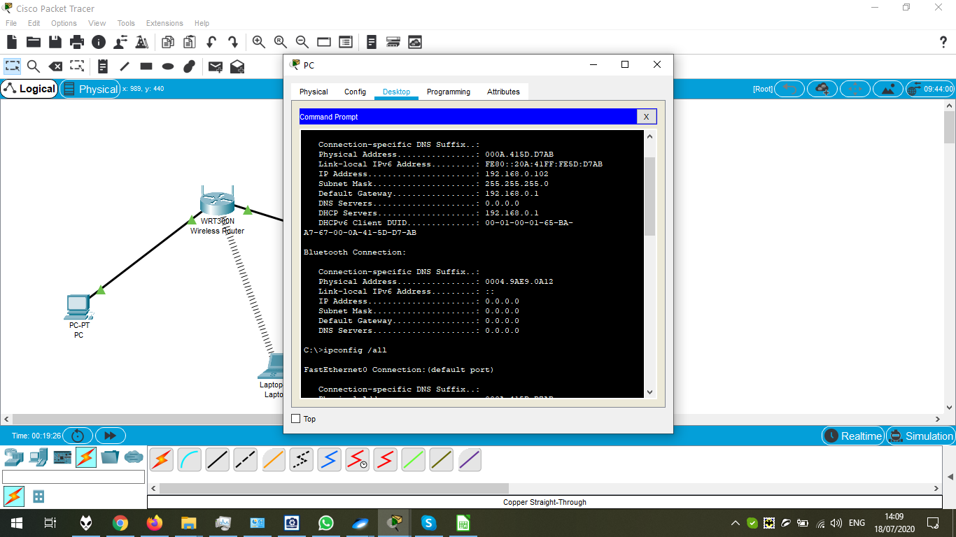

Configuring the DHCP Options of Server:

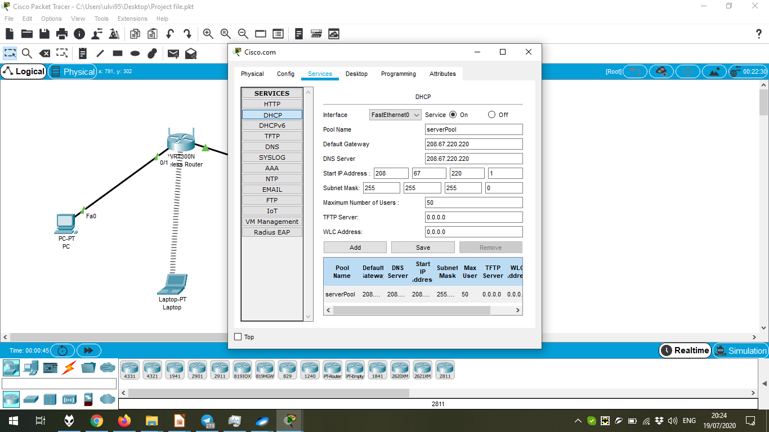

Configuration of DNS of the Server:

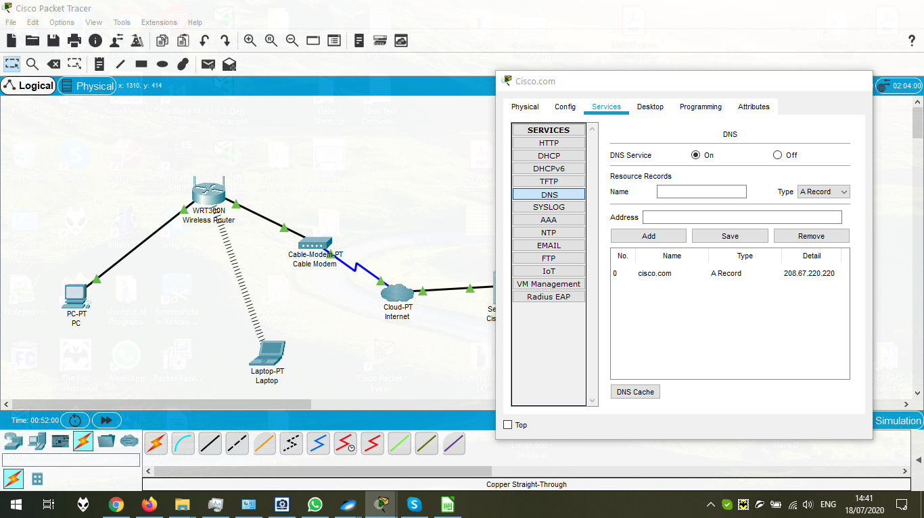

Configuration of Cisco-PT (Internet). We should choose Cable option in the Ethernet options first to connect as in the screenshot:

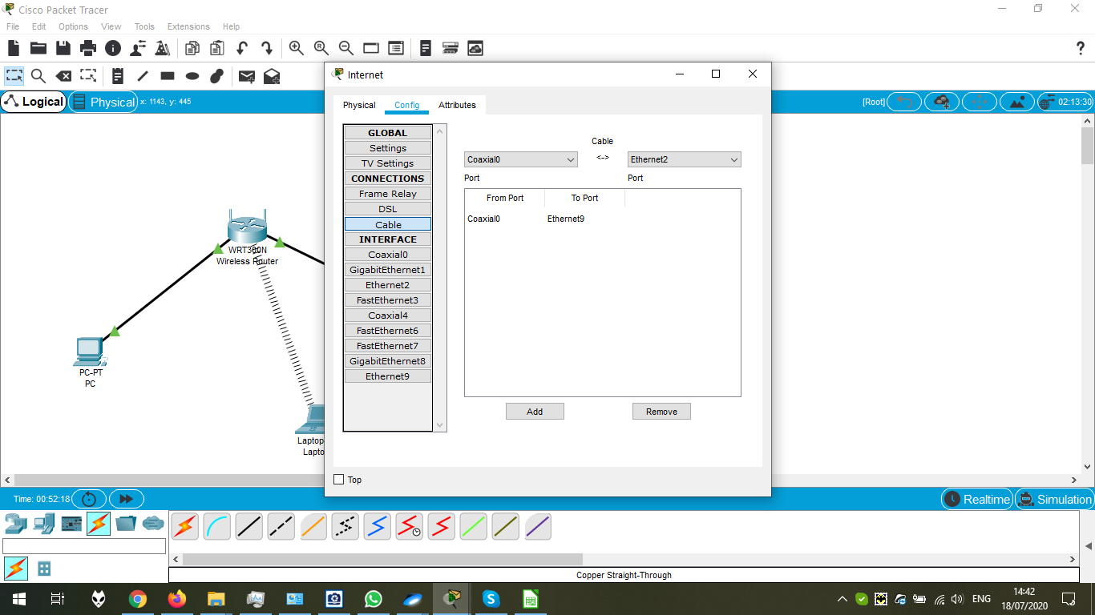

Defining the Global configurations of Server.

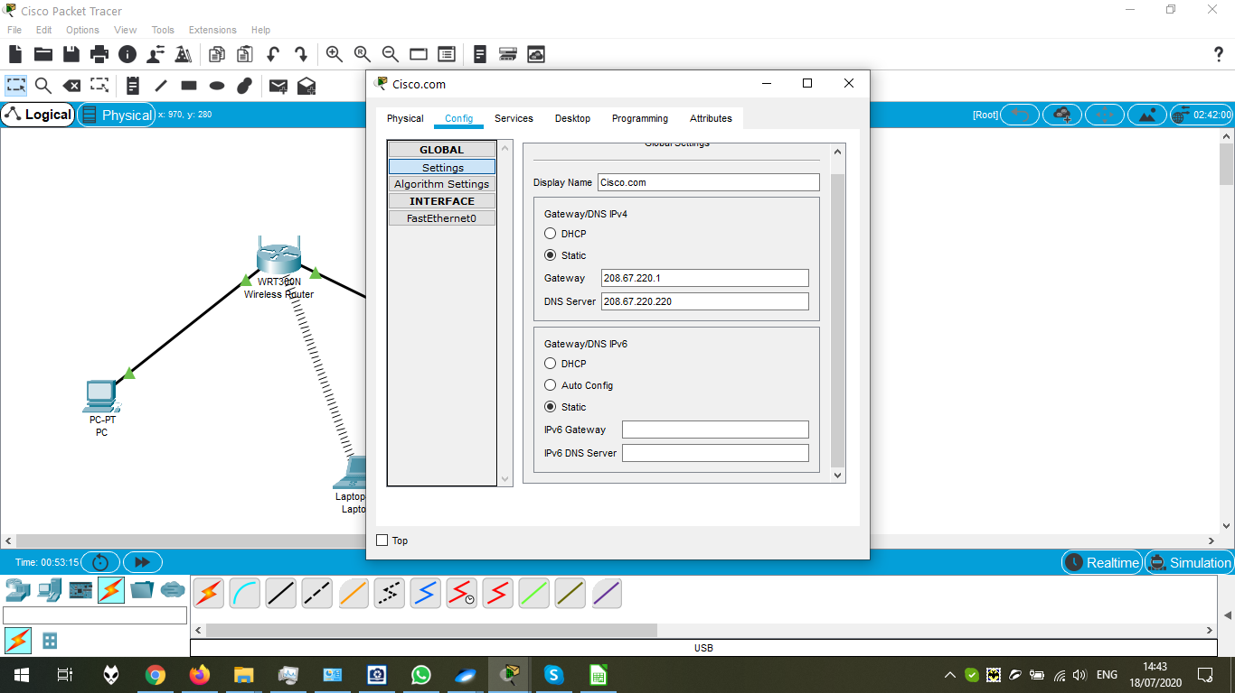

Defining the FastEthernet options of the Server:

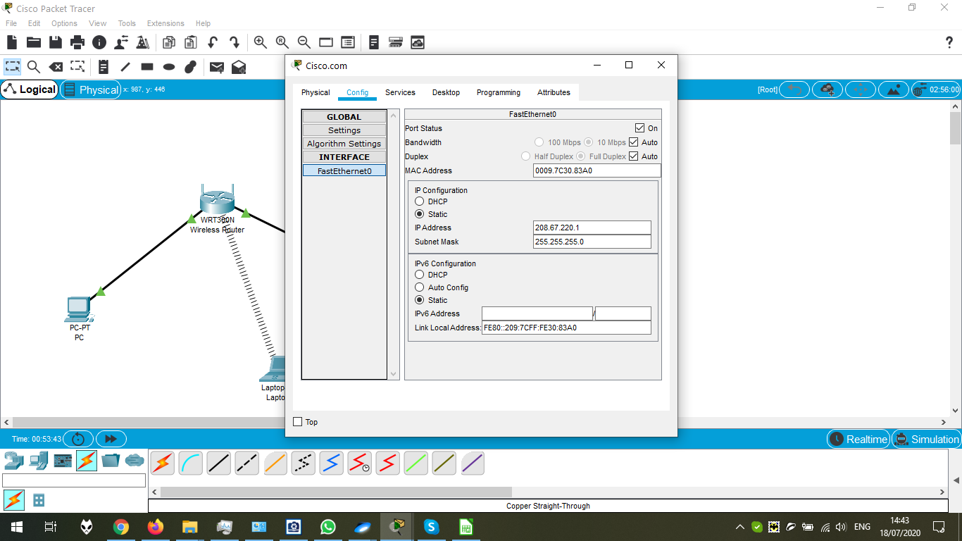

The final picture.

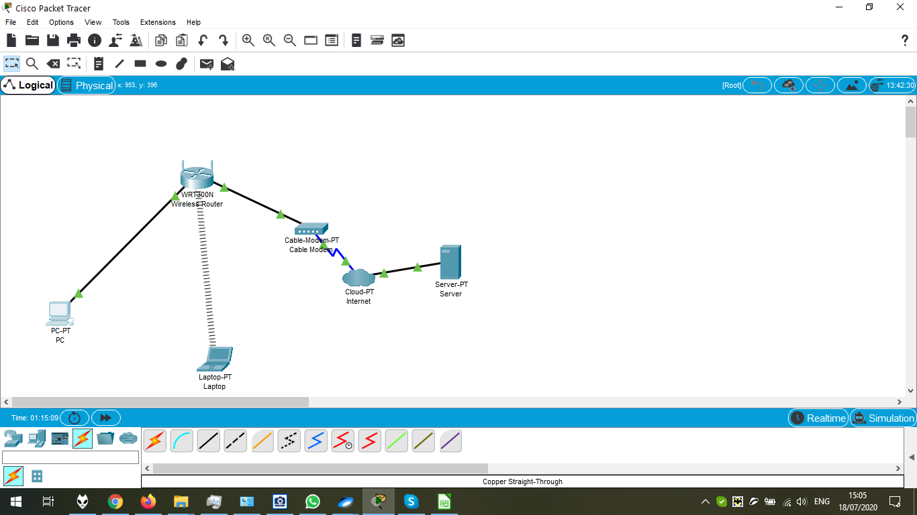

To test the ping, we should execute sequentially the commands ipconfig /release , ipconfig /renew , ping Cisco.com

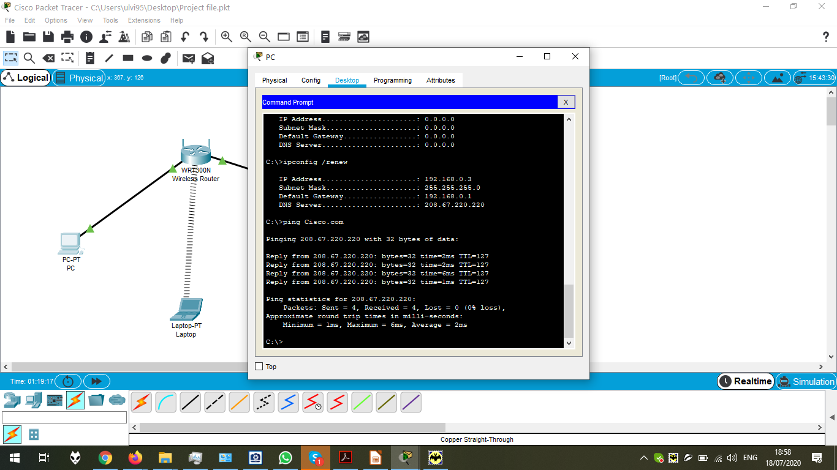

Chapter 3.1.1.1 Preview

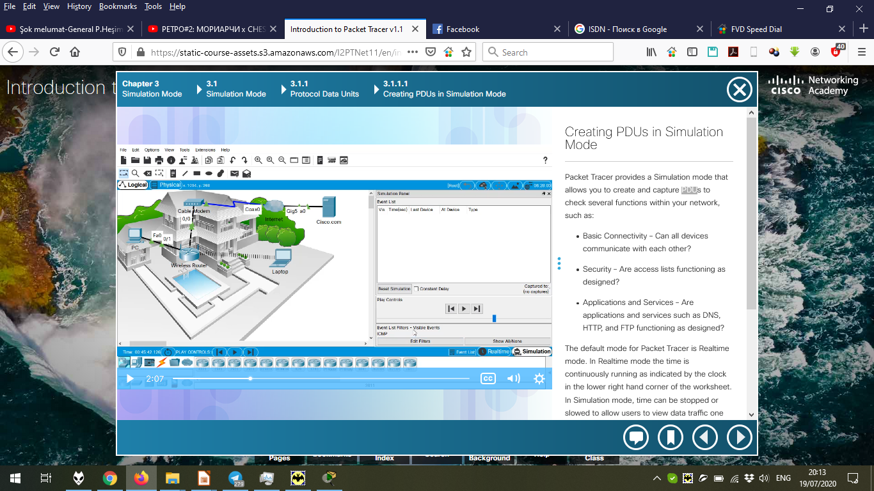

Chapter 3.1.1.2 Preview

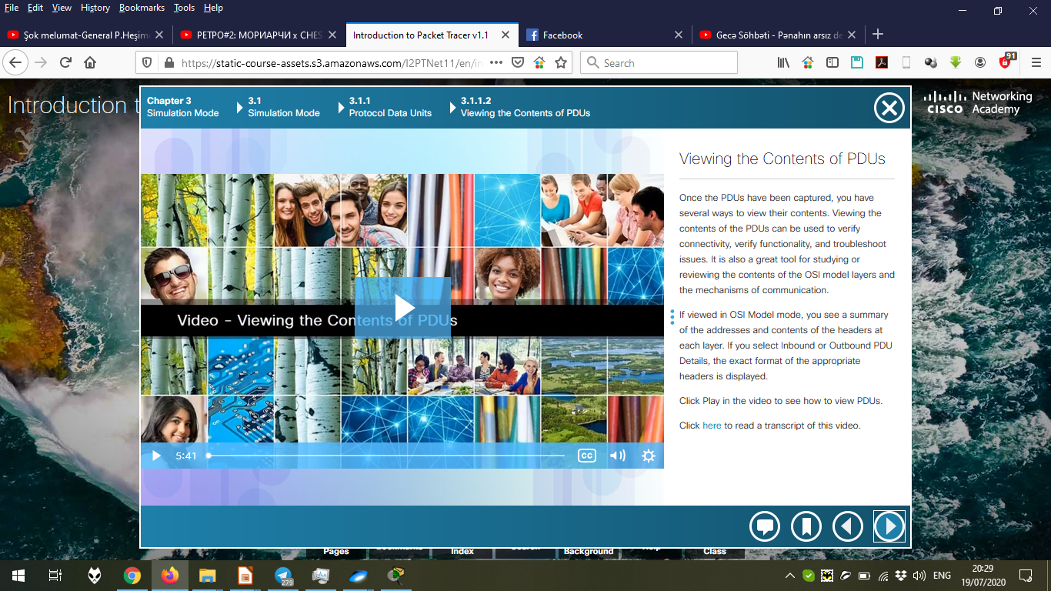

Chapter 3.1.1.3 Preview

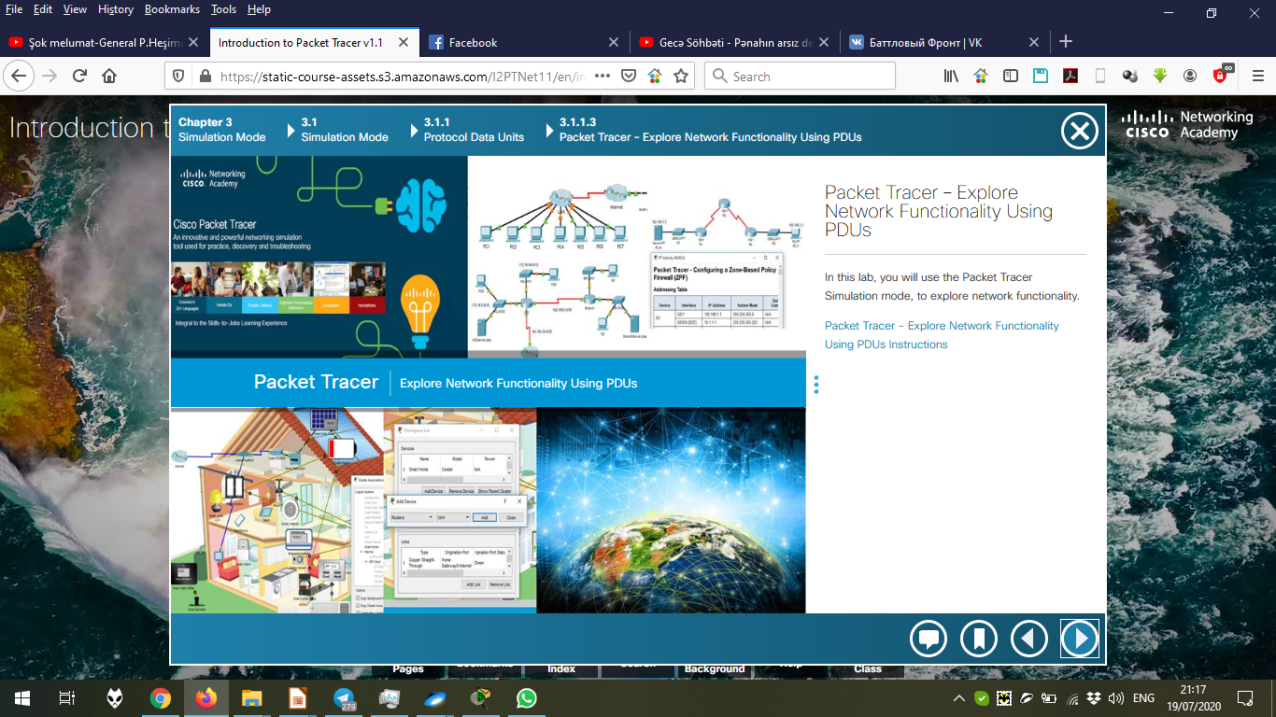

PDF “Packet Tracer – Explore Network Functionality Using PDUs”

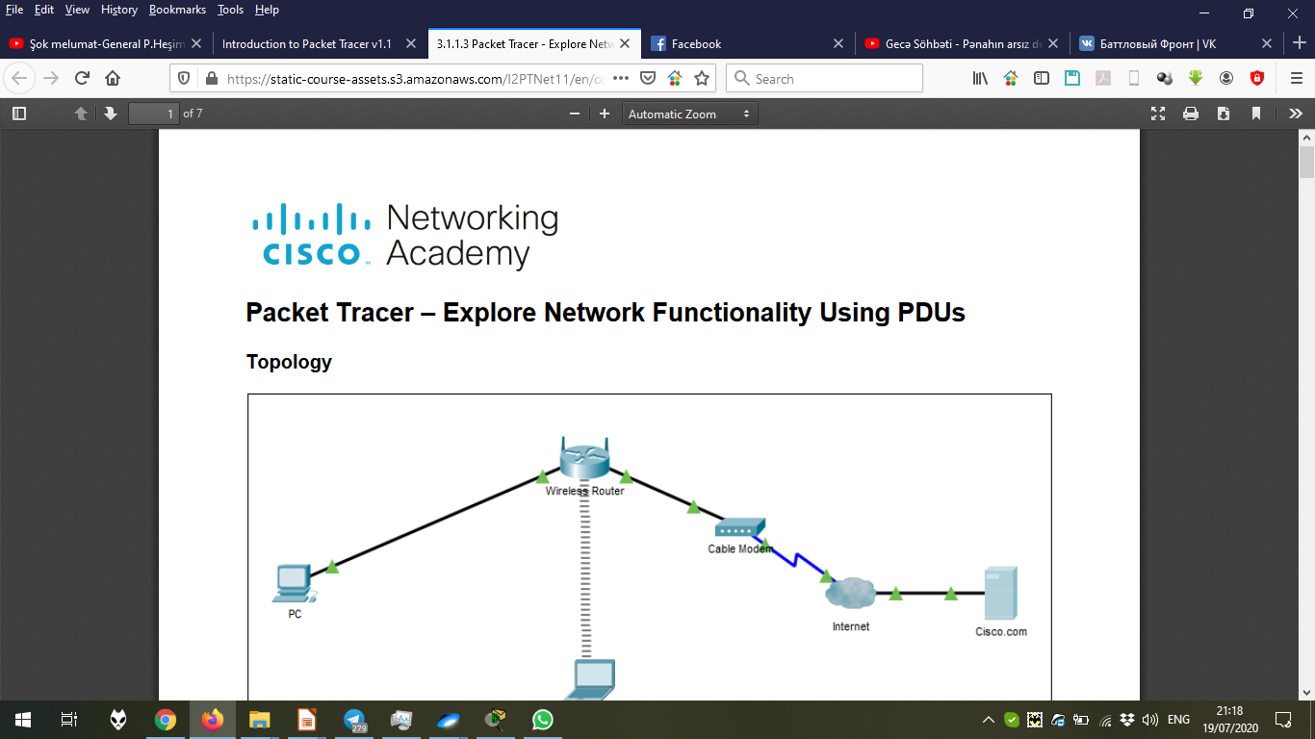

The toolbar of the Simulation Mode:

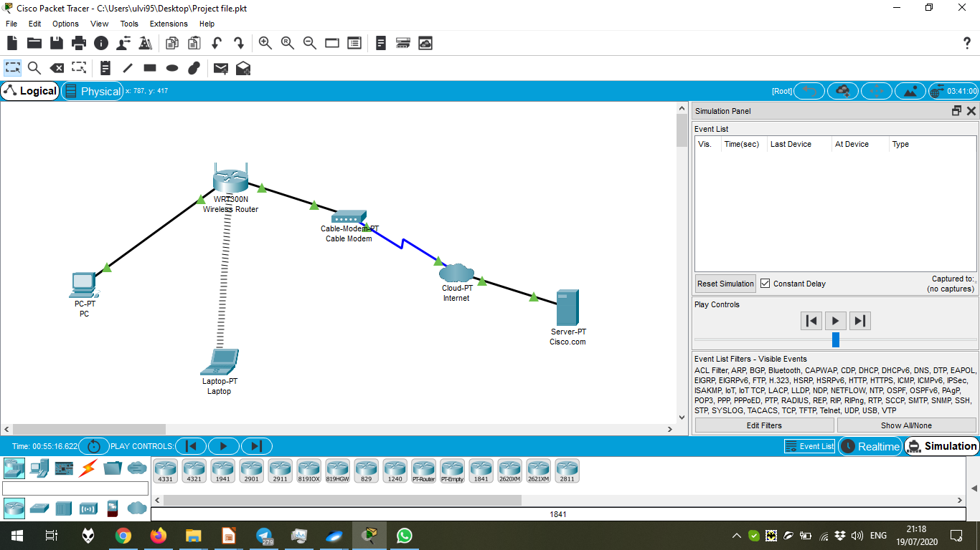

Adding the source and the destination of the Simple PDU.

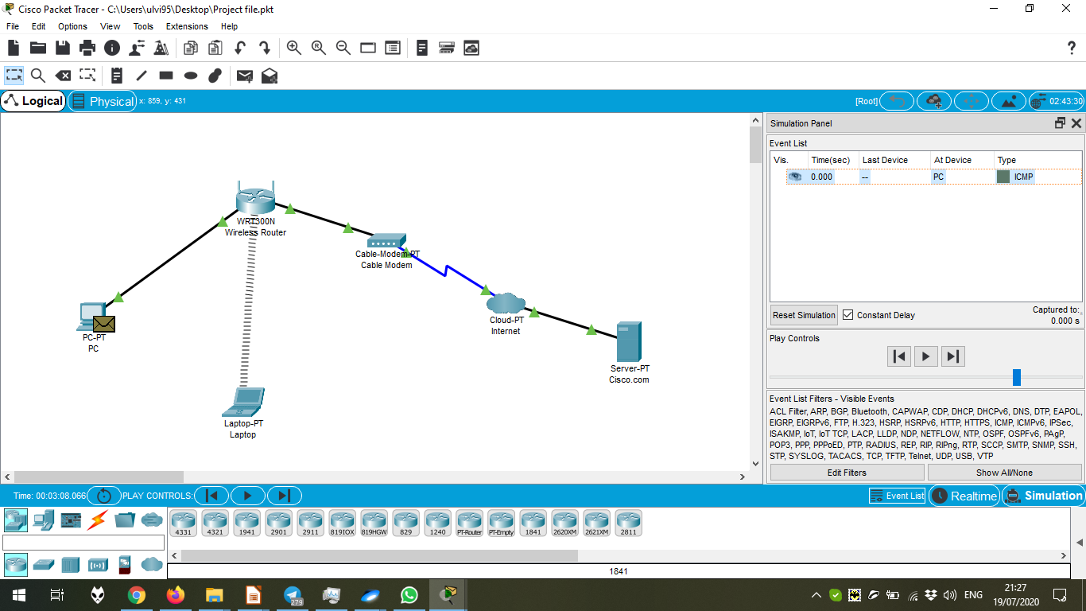

After adding the source and the destination of the Simple PDU.

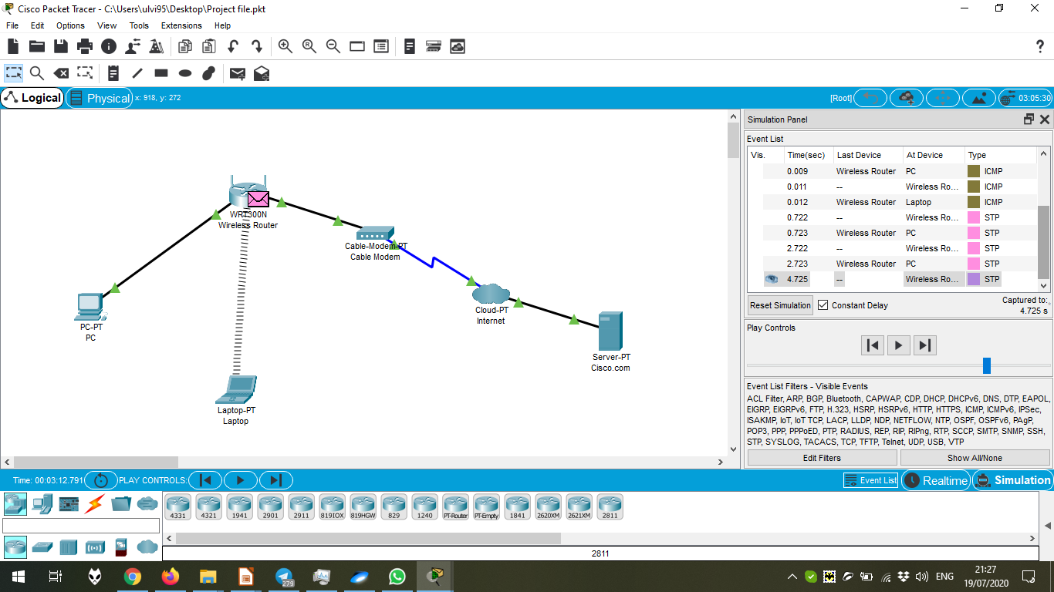

Checking the record in the simulation mode (OSI Model):

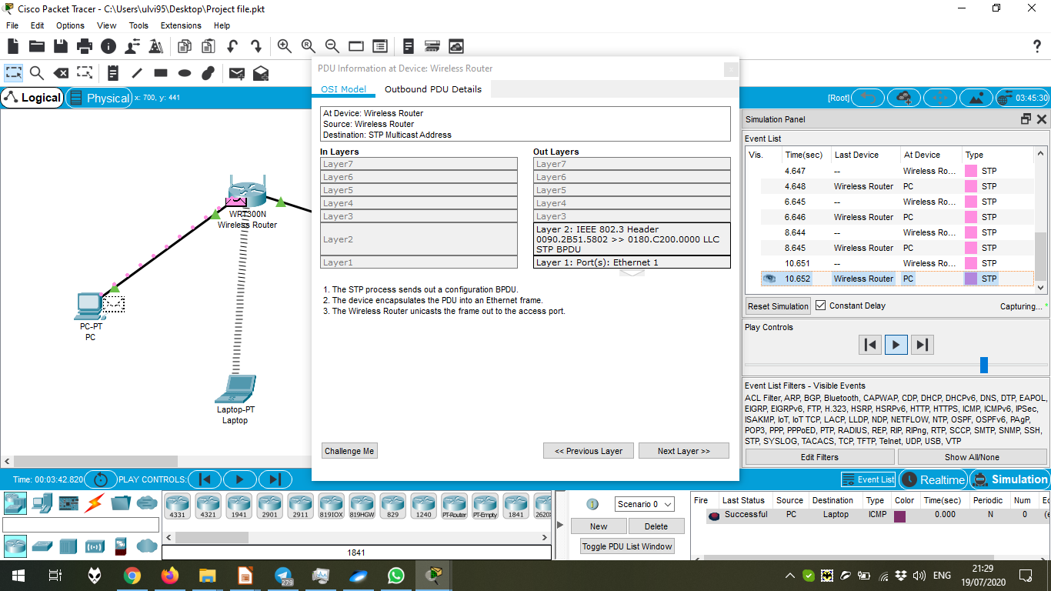

Another checking the record in the simulation mode (OSI Model):

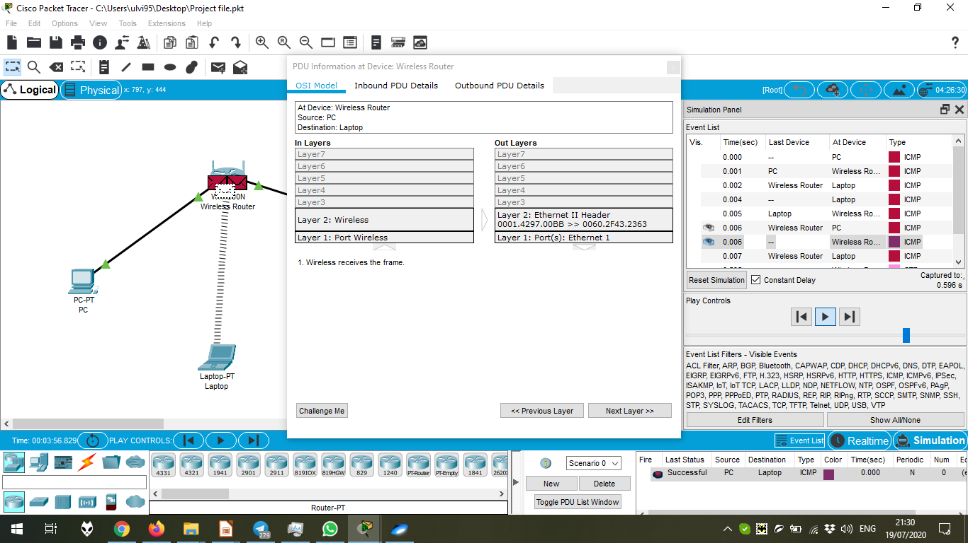

Checking the record in the simulation mode (Outbound PDU Details):

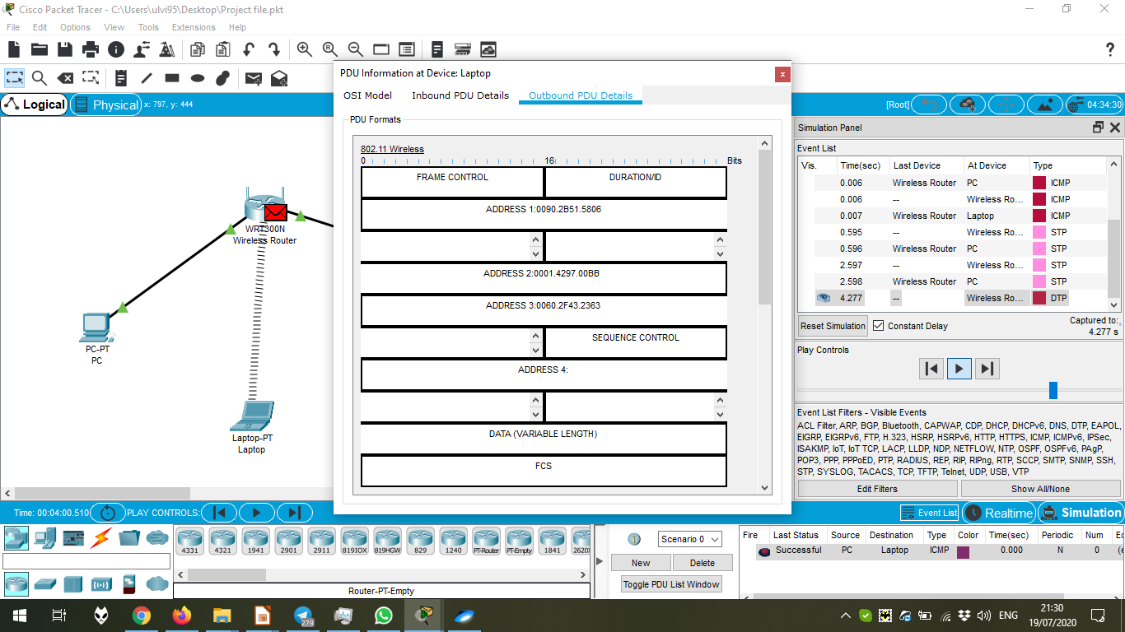

Checking the record in the simulation mode (Inbound PDU Details):

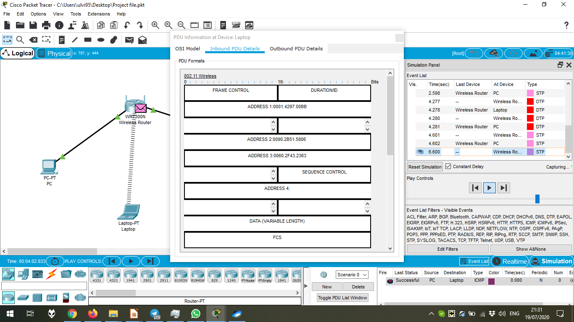

Removing the PDU:

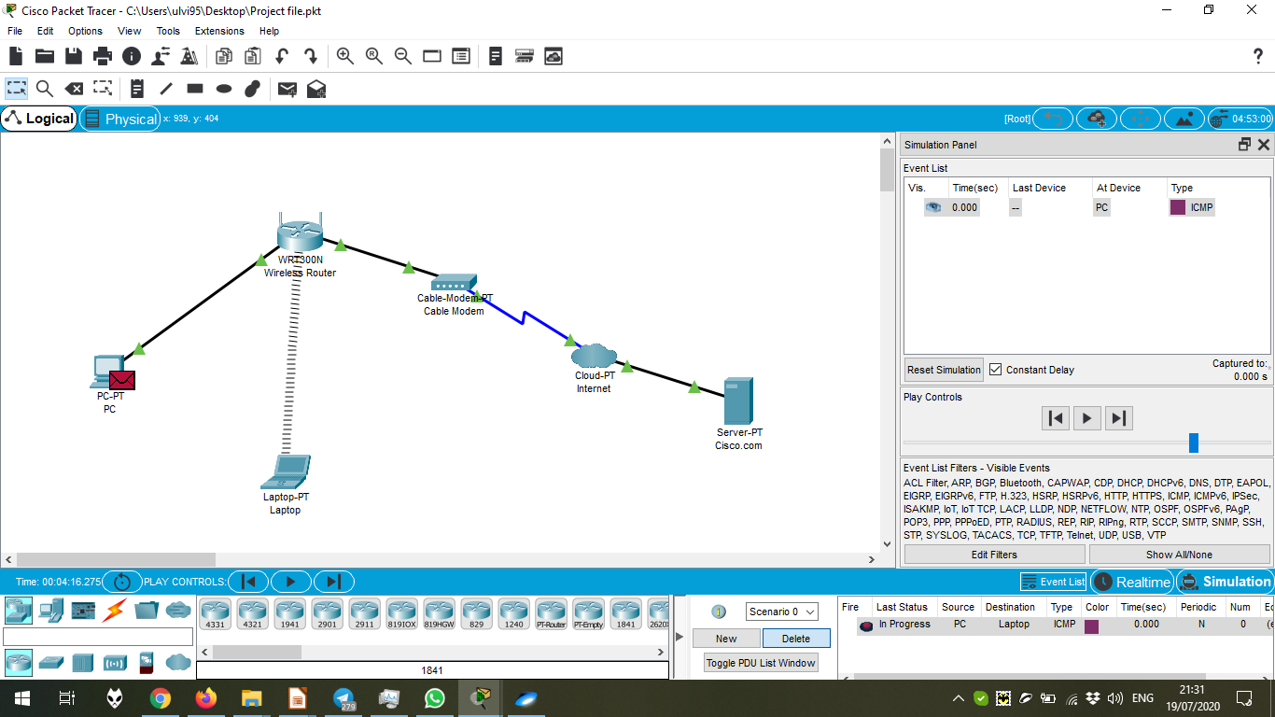

The PDU is removed.

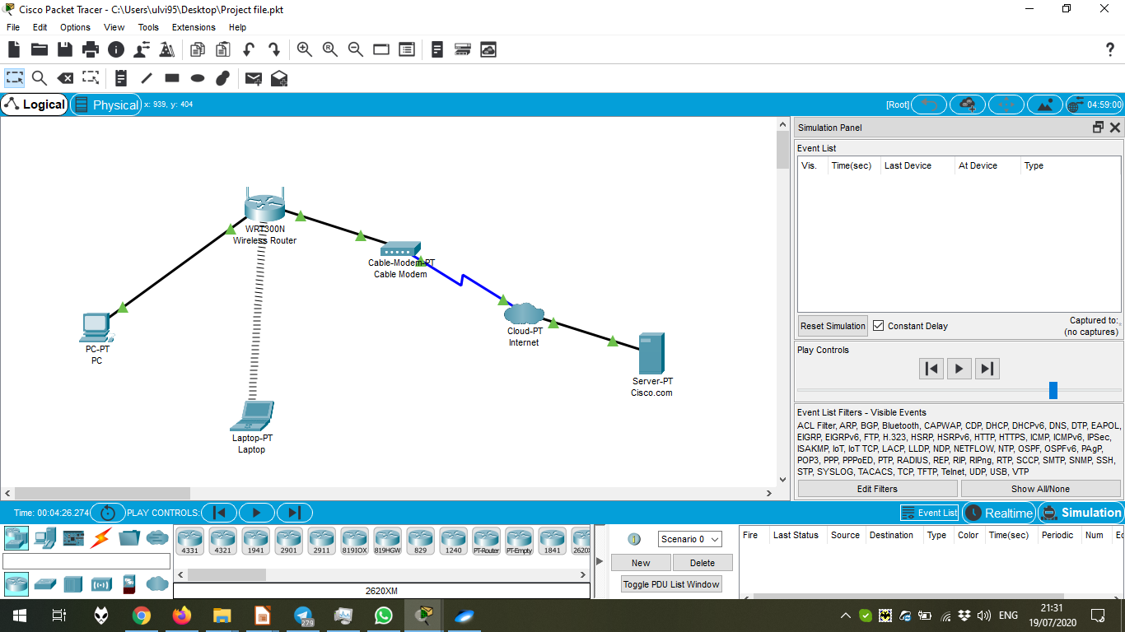

Adding Complex PDU with the sequence number and the repeating interval:

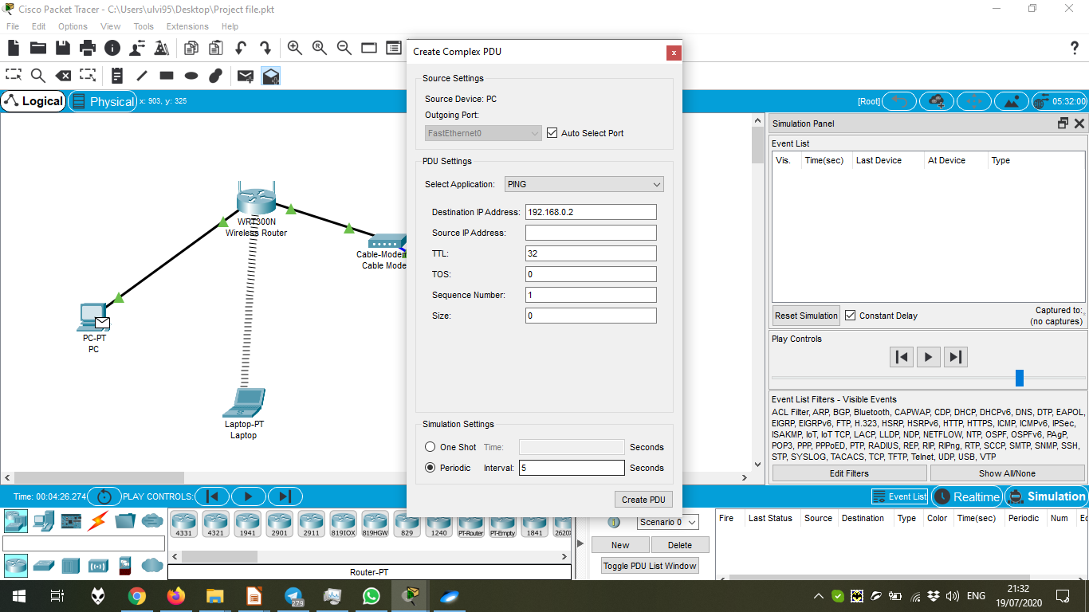

The start of the Simulation.

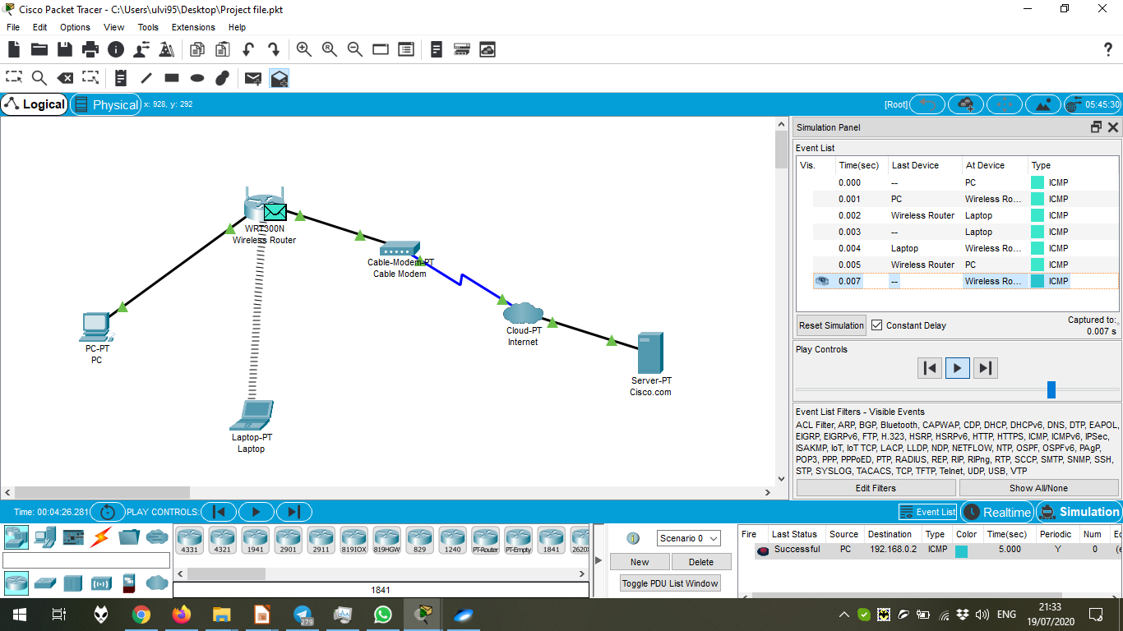

The simulation is repeating after 5 seconds:

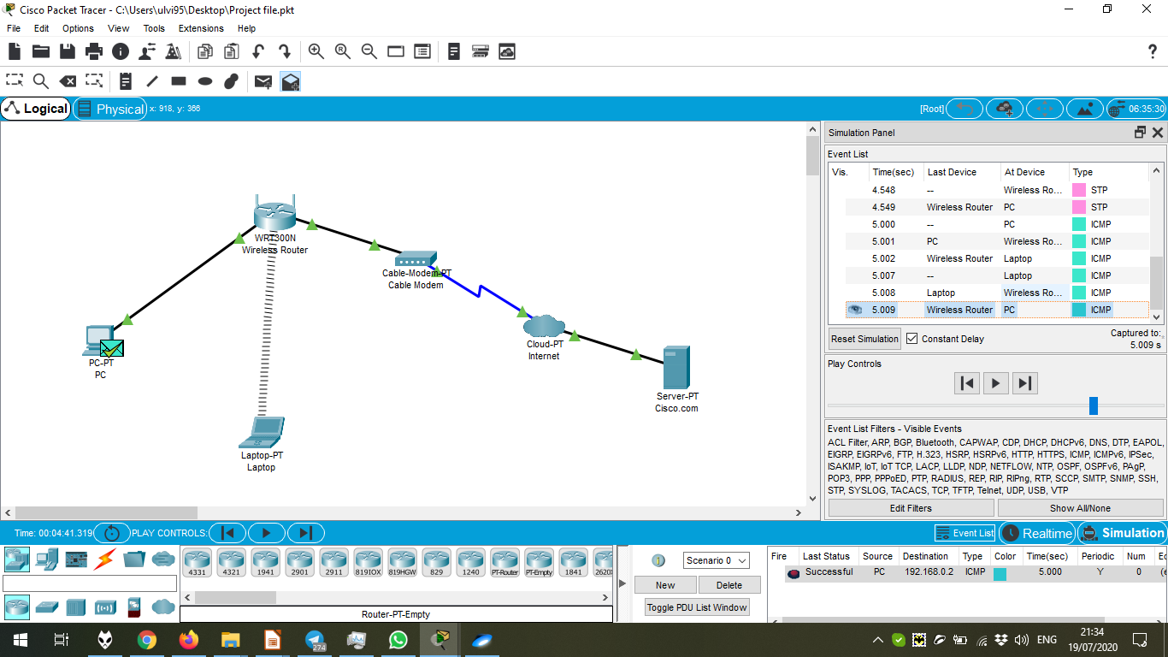

Chapter 4.1.1.1 Preview

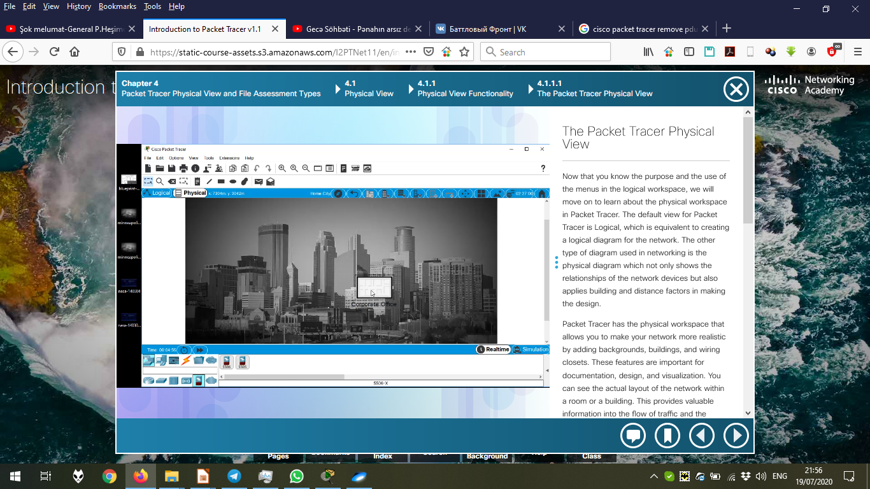

The default Physical view:

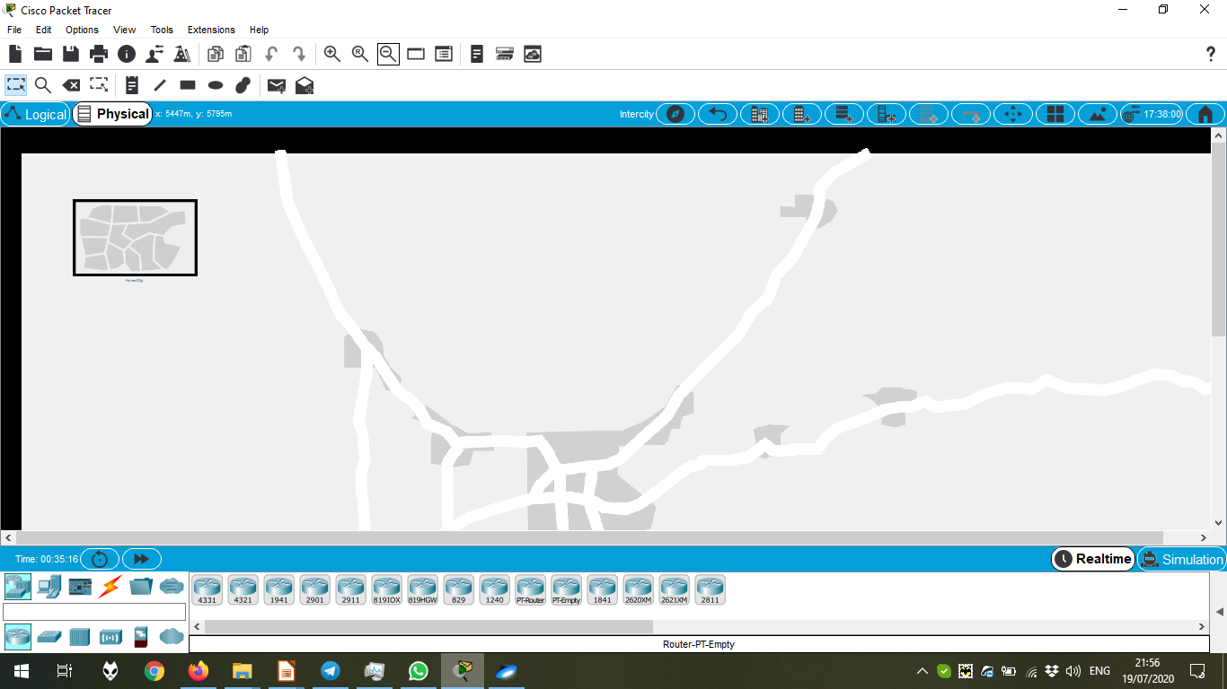

Chapter 4.1.1.2 Preview

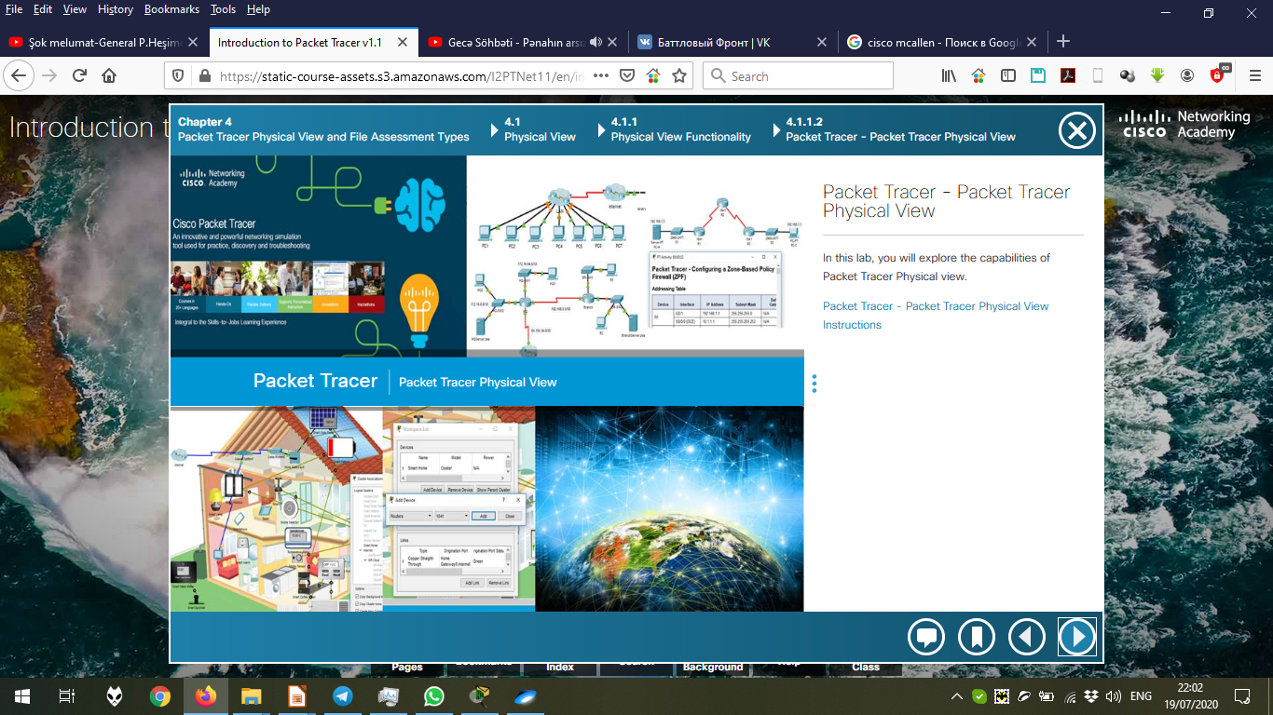

PDF “Packet Tracer – Packet Tracer Physical View”:

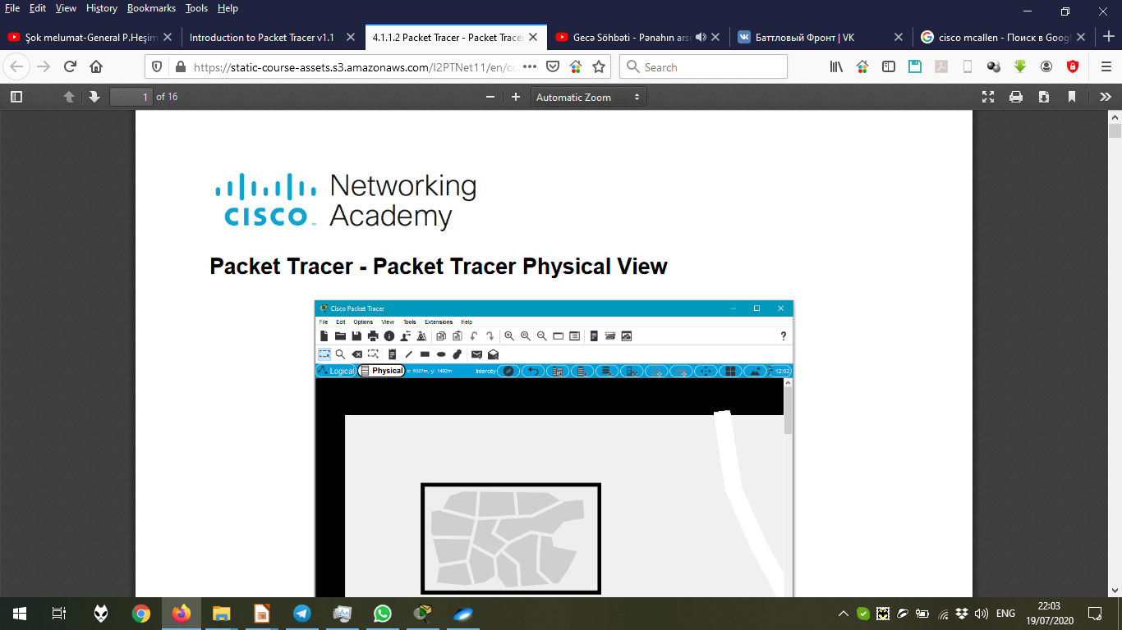

After changing Backgrorund in the Intercity view by “Set Background Image → Browse”:

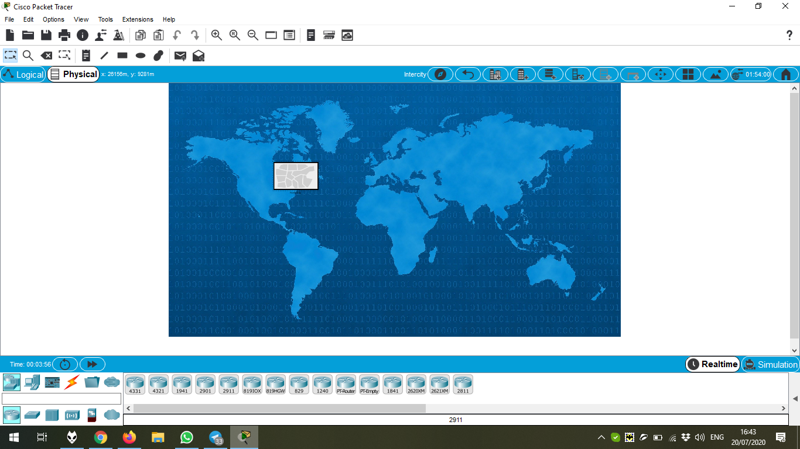

After changing Backgrorund in the Home City view by “Set Background Image → Browse”:

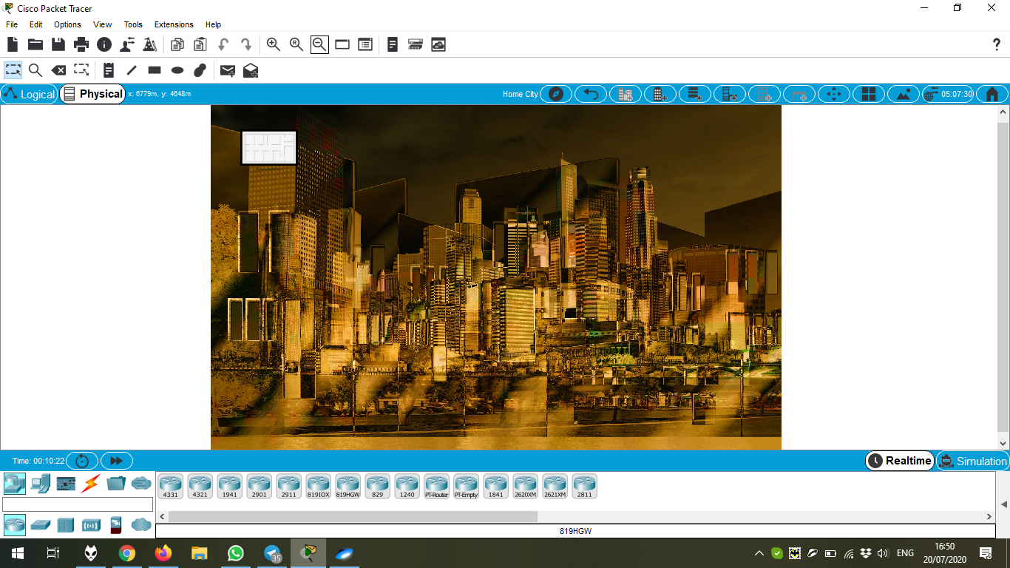

Adding devices in the Main Wiring Closet:

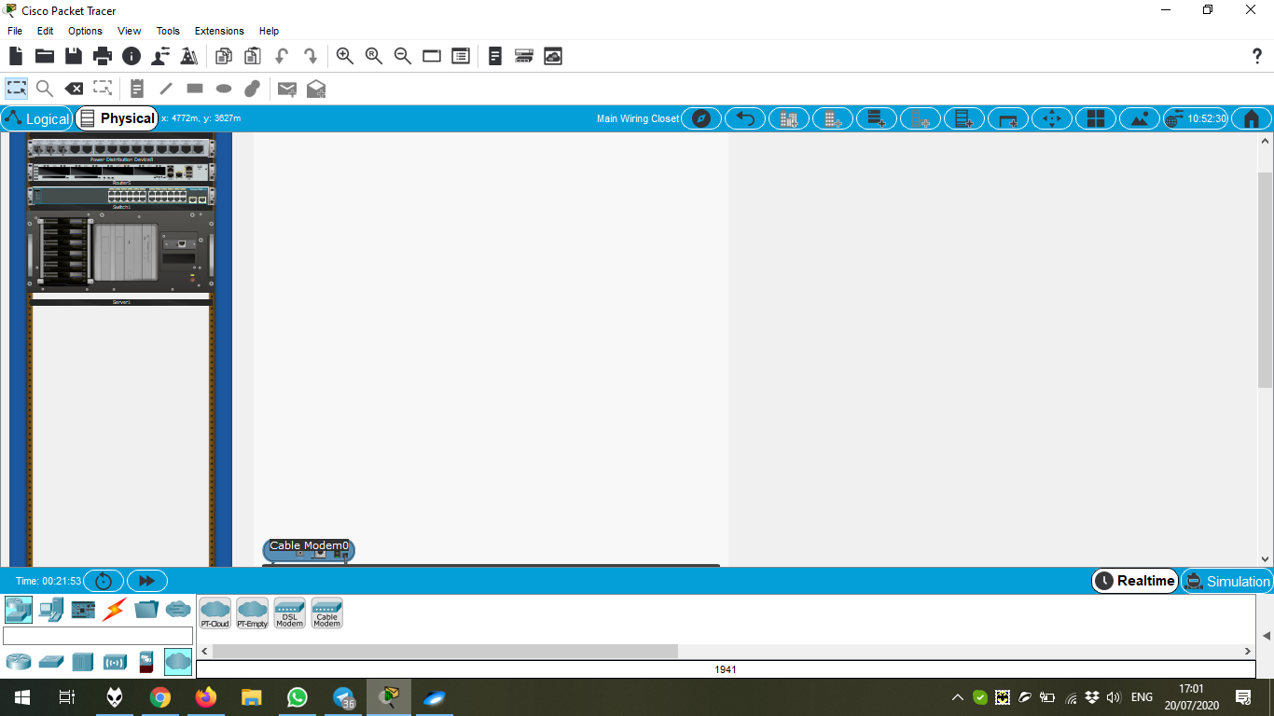

Configuring the devices of Physical View in the Logical View:

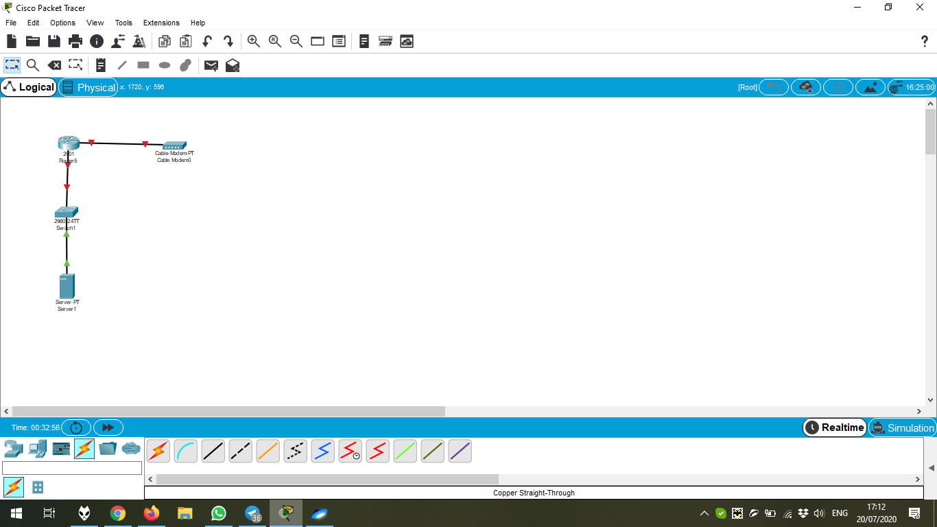

Now, we can see wires:

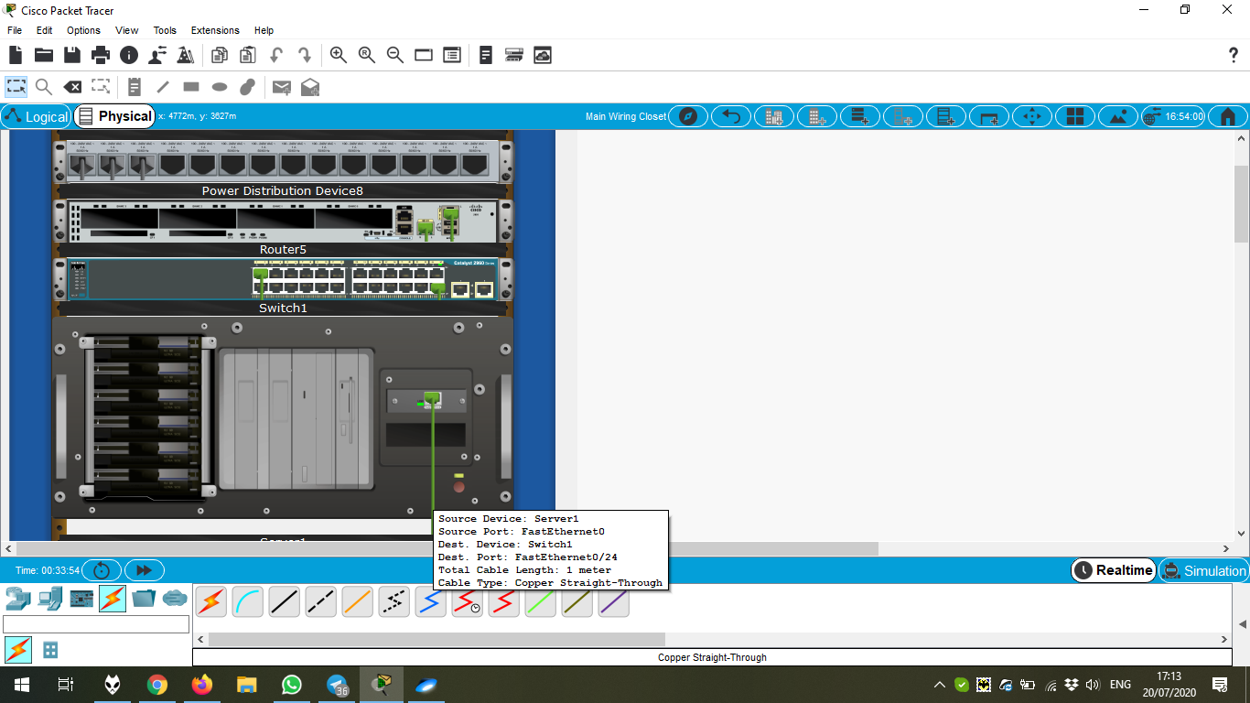

Chapter 4.2.1.1 Preview

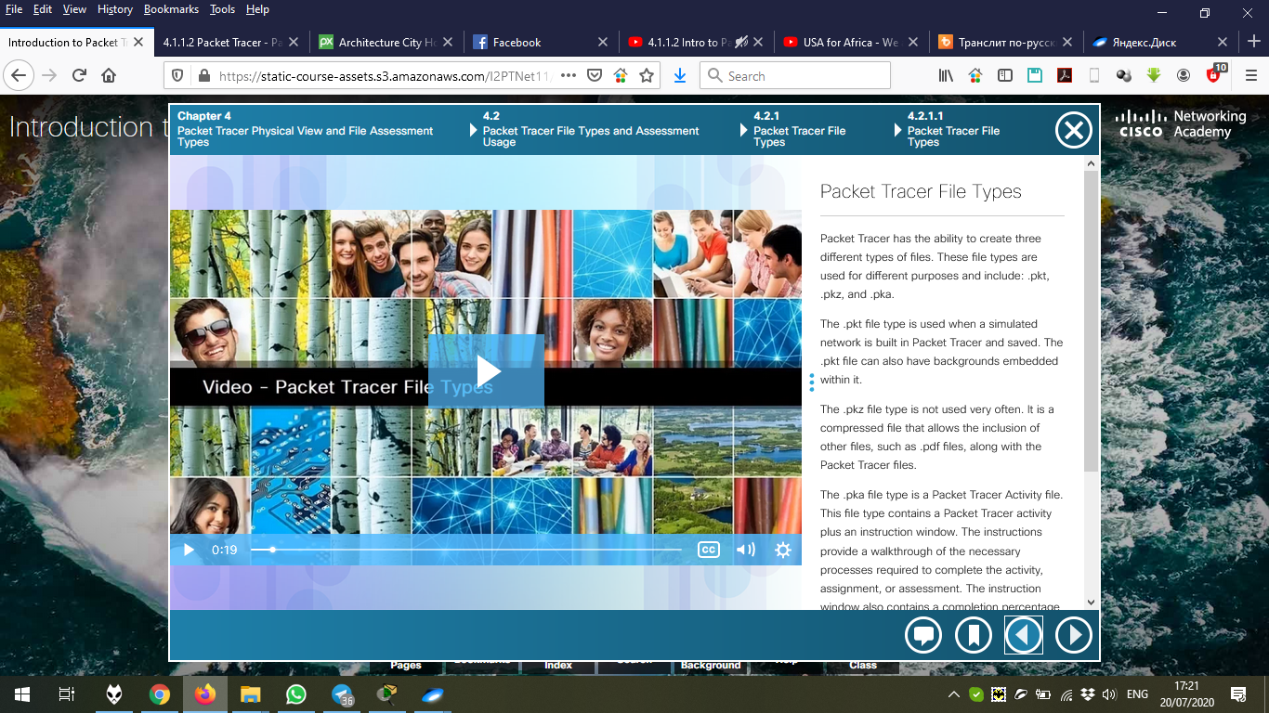

Chapter 4.2.2.1 Preview

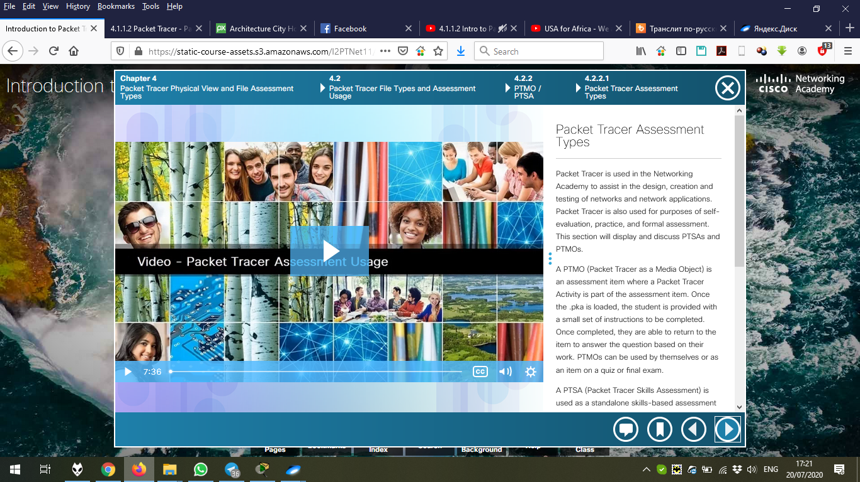

Chapter 4.3.1.1 Preview

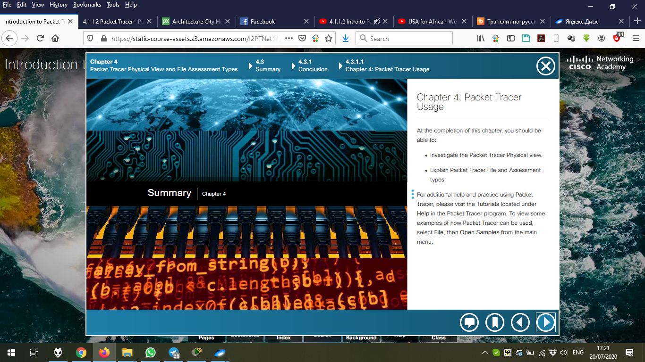

The quiz after Chapter 4.

